Instructions:

A generic SMART goal has been prewritten for schools to copy and paste into the Attendance Plan. However, each school must access the SIP Attendance Dashboard to identify its own attendance data and enter the school-specific attendance percentage for its goal. To review last year’s SIP goals, select “View 25–26 SIP Goals” in the lower-left corner of the dashboard.

Please use the link below to access the SIP Attendance Dashboard to complete your goal for School Year 2026-2027. SIP Attendance PowerBI Dashboard.

2026/27 Attendance Plan School Improvement Plan (SIP)
Atlantic Technical College and High School (2221)
This Attendance Plan takes a team approach to ensure that students have a welcoming and supportive educational environment. This plan identifies school-based team members, SMART goals, foundational supports, and three tiers of interventions and supports to help promote and improve student attendance.
Tiered strategies and interventions include these 5 core ingredients:
- Monitor Data
- Engage Students and Families
- Recognize Good and Improved Attendance
- Provide Personalized Outreach
- Remove Barriers

Attendance Team
 | Student | Varies by student
 | Parent | Varies by student
 | Position | Name
1 | Teacher | Varies by student
2 | Principal | Neeta Rancourt
3 | Assistant Principal | Vicky LaPorte
4 | Attendance Clerk | Tijuana Rolle
5 | School Counselor(s) | Miladys Puddie, Kimberly Jackson
6 | ESE Specialist | Debbie Evangelista
7 | School Nurse | De Andrea Dixon
8 | School Social Worker(s) | Kimberly Fort
9 | Other (Optional)

Chronic absenteeism occurs when a student misses 10% or more of the school year for any reason, including excused absences, unexcused absences, and suspensions. For example: In an 180-day school year, a student is considered chronically absent after missing 18 or more days, regardless of the reason for the absences. Please use the

Key points:
- Counts all absences, not just unexcused ones.
- Focuses on total instructional time missed, not attendance codes.
- Differs from truancy, which refers only to unexcused absences.
- Chronic absenteeism is used as an indicator for academic risk and is often part of accountability systems.

Please use the link to access the SIP Attendance PowerBI Dashboard to complete your goal for School Year 2026-2027. To review last year’s SIP goals, select “View 25–26 SIP Goals” in the lower-left corner of the dashboard.

Attendance Goal
Goal 1: Total Chronic  Absenteeism | By June 2027, our goal is to reduce the percentage of students who are chronically absent by at least 1 percentage point, from 24.7% to 23.7% or lower.

Early Interventions and Statutory Attendance Requirements (F.S. 1003.26)

Florida law requires schools to track excused and unexcused absences and contact the home when an absence is unexcused or the reason is unknown. Early intervention helps prevent patterns of nonattendance and supports student learning. Each school is required to take the following steps to promote regular attendance:

Step 1: Parent Phone Call
For each unexcused absence, or any absence with an unknown reason, the student’s teacher must contact the parent or guardian to determine the reason for the absence. Document all contact attempts and outcomes in FOCUS.

Step 2: Teacher Reporting of a Possible Pattern of Nonattendance
The teacher must report to the principal or designee any student who has five (5) unexcused absences in a calendar month or ten (10) unexcused absences within a ninety (90) calendar-day period, whichever occurs first.

Step 3: Mandatory Consideration for Child Study
The principal or designee reviews the student’s attendance to determine if there is a possible pattern of nonattendance. If the absences are not authorized under district attendance policies, the case must be referred to the Collaborative Problem-Solving Team (CPST) to determine the reason for the absences and identify appropriate supports. If no pattern is found, the school should continue to monitor the student’s attendance.

Step 4: Required Collaborative Problem-Solving Team Interventions
- If the CPST determines a pattern of nonattendance is developing, whether absences are excused or unexcused, a meeting with the parent must be scheduled to identify potential interventions.
- The CPST may allow the parents to participate virtually or by telephone if they are unable to attend in person.
- If the parent or student fails to attend, the CPST must proceed with the meeting and develop written recommendations based on available information.
- Recommendations must be documented and provided to the parent within seven (7) days of the CPST meeting.
- The CPST must identify the underlying causes of truancy and implement appropriate interventions or referrals, including addressing contributing environmental factors (e.g., in-person or cyberbullying) and providing available support options.

Additional Interventions and Referrals: The CPST may provide additional supports, including frequent parent contact, and in collaboration with the school social worker, a referral to the Department of Juvenile Justice’s (DJJ) approved provider for voluntary family services. A signed release of information is required to submit the referral; the information may be shared with the parent to initiate services themselves. In Broward County, two agencies provide these services:
- Lutheran Services of South Florida
- Prevention Central

Step 5. Diligence, Documentation, and Escalation
The CPST must diligently implement interventions and maintain documentation of parent contacts, meetings, attendance data, services provided, and outcomes.

Step 6. Continued Student Noncompliance
Elementary Schools: Follow the referral process for the Broward Truancy Intervention Program (BTIP). BTIP may offer additional interventions, recommendations, and monitoring, or refer the case to the State Attorney’s Office if noncompliance continues.

Secondary Schools: After exhausting attendance-related interventions, the case should be referred to a DJJ provider, with parent consent. The school social worker shall request a signed release of information from the student’s parent. The provider will then offer voluntary family services, schedule a case staffing meeting, and may recommend a CINS/FINS referral per F.S. 984.151. If the student’s parent(s) or legal guardian(s) decline services through the CINS/FINS program, the CPST and school social worker will continue to support and provide interventions to the student and family, including referrals to community resources as needed to promote the importance of school attendance.

Connecting Statutory Attendance Requirements to Tiered Interventions
Florida’s statutory attendance requirements establish clear expectations for timely monitoring, parent contact, documentation, and escalation when a pattern of nonattendance is identified. The tiered intervention framework supports this process by helping schools respond early and systematically using Tier 1 strategies to promote regular attendance for all students, Tier 2 interventions to provide targeted support when warning signs emerge, and Tier 3 interventions to address intensive or persistent attendance concerns through coordinated problem-solving, family engagement, referrals, and ongoing progress monitoring.

Foundational “Whole School” Supports
The table below represents the foundation of our three tiers of intervention in the Attendance Plan. These foundational supports are the building blocks of effective schools that promote attendance. When resources are not in place, it is the responsibility of the school and community to put them in place.

Physically healthy learning environment | Attendance recorded daily, promptly and accurately | Positive relationships between school staff, students, and families | Support for all families to facilitate learning at home and at school
Welcoming, social- emotional safety, trauma- informed school climate | Active engagement of parents and students in planning and problem- solving | Predictable daily/weekly routines, rituals and celebrations | School regularly communicates methods to report excused absences
Access to technology | Culture of continuous improvement | Enrichment activities and clubs | Access to Learning Supports
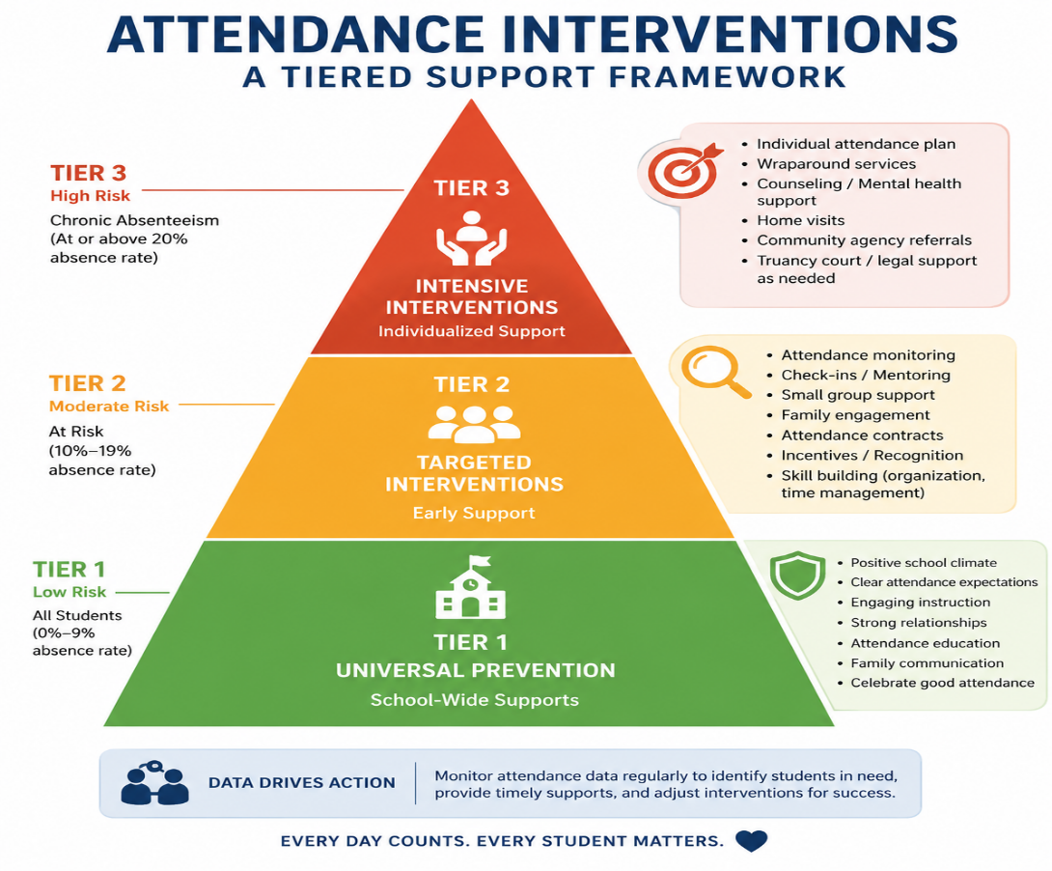
Tiered Attendance Interventions
Tier 1: Schoolwide Attendance Campaign – Successful Tier 1 strategies rely on foundational supports and represent universal strategies intended to encourage regular attendance for all students and prevent absenteeism.

Monitor Data (Tier 1)
  - Teachers will record attendance at the beginning of the school day (K-12) and at the start of each class period (grades 6-12). Teachers will update attendance as needed.
  - Excused absences are updated daily by the attendance clerk. Absences are excused under the direction of the principal and designated staff according to the District Attendance Policy.
  - Review schoolwide attendance data with the Collaborative Problem-Solving Team and/or Response-to- Intervention Team.
  - Monitor and review attendance data from FOCUS. Metrics include excused and unexcused absences, attendance categories, and percentage of days absent for each student.
  - Monitor attendance input from teachers and attendance clerks to ensure that all students have an attendance code for each school day.

Engage Students and Families (Tier 1)
  - The school website includes a “Report an Absence” page, accessible from both the Home Page and the Contact menu, which informs families and stakeholders how to report an excused absence through the Online Absence Reporting Form, FOCUS Parent Portal and mobile app, voice message, or written note. The page also provides information about acceptable reasons for excused absences and attendance reporting procedures.
  - Upon each unexcused absence, or any absence for which the reason is unknown, the student’s teacher(s) is required to contact the parent.
  - Use the District Attendance Dashboard to regularly share appropriate information regarding current data for student attendance at parent conferences, PTA/PTSA meetings, SAC meetings, SAF meetings, student assemblies, morning announcements, school newsletters, and ParentLink communications. (SAC is the School Advisory Council; SAF is the School Advisory Forum.)

Recognize Good and Improved Attendance (Tier 1)
  - Regular attenders are at school more than 95% of school days. Promote regular attendance during morning announcements, lunch periods, afternoon announcements, a common bulletin board, and/or student assemblies.
  - Congratulate regular attenders and their parents using ParentLink. School-based recognition may include offers from community partners supporting good attendance with coupons or vouchers.

Provide Personalized Outreach (Tier 1)
  - Maintain accurate parent and guardian contact information, including current phone numbers and email addresses, and encourage families to update this information whenever changes occur.
  - For each student absence, a robocall will be initiated to the parent/guardian to include a voice message, text message, and email to notify them of a recorded absence and the expectation of the parent/guardian to report the reason for absence.
  - Include attendance information on student report cards to display the number of days present, absent, and tardy. Accurate attendance recordkeeping helps facilitate this personalization.

Remove Barriers (Tier 1)
  - Promote awareness of the free school breakfast program available to all students, including the cafeteria opening time, so families understand early drop-off options and can support timely student arrival, particularly at the elementary level.
  - Invite parents, caregivers, and community partners to participate in meetings focused on identifying and addressing barriers that impact student attendance. Discussion topics may include mental health, transportation, homelessness and McKinney-Vento supports, child abuse prevention, domestic violence, foster care, and other needs identified by stakeholders.
  - Provide or coordinate health interventions such as flu shots, dental checkups, asthma management plans, and lice screenings.
Tier 2: Strategies and Early Interventions to Improve Attendance – Using attendance as an Early Warning Indicator, Tier 2 interventions can help prevent a student from falling into chronic absenteeism or help stabilize attendance. These students and families should receive personalized attention as part of the engagement strategy.

Identifying Tier 2 Students
Tier 2 Warning Signs: Pull the Early Warning Signs (EWS) Report to identify indicators such as prior year chronic absenteeism; 3 or more absences in the first 4 weeks of enrollment; and absent 10% or more school days at any time during the school year.
Chronic Absenteeism: Absent 10% or more school days. All absences count as missed days of instruction (including excused, unexcused, and suspensions). Early interventions for these students are recommended before the end of September and should continue throughout the school year.

Monitor Data (Tier 2)
  - Review the Excessive Absence Report in FOCUS every school week. Notify teachers of students who may be at-risk for attendance concerns.
  - Monitor students with five (5) unexcused absences within a 30-day calendar period. Determine whether extenuating family circumstances exist and provide appropriate interventions and supports as needed.
  - Teachers will monitor attendance using the online attendance book and FOCUS. Consult with support staff and CPST/MTSS for help identifying the root causes of the student’s absenteeism.
  - Collaborate with the CPST/MTSS team to monitor and discuss interventions for students with a pattern of nonattendance. Identify barriers, assign supports, and monitor progress.

Engage Students and Families (Tier 2)
  - Utilize “Attendance Success Plans” and “Attendance Contracts” for students with excessive absences (excused or unexcused). Help families set attainable goals and establish successful home routines.
  - Contact the parents of the student by phone, email, or virtual meeting when there is a concern about the student’s attendance. Communication with parents should be positive and supportive.
  - Refer the student to appropriate supports as soon as possible when barriers are identified (homelessness, food scarcity, physical or mental health issues, illness of a family member, etc.).

Recognize Good and Improved Attendance (Tier 2)
  - Recognize students who are improving their attendance. Short-term, attainable goals can help establish successful routines for students struggling with additional external barriers.
  - Welcome students back after absences with positive, supportive communication. Focus on their return and avoid negative or punitive comments.
  - Routinely recognize good and improved attendance schoolwide. Meaningful social expectations regarding attendance become part of the school culture and encourage students to attend regularly.

Provide Personalized Outreach (Tier 2)
  - Assign an “Attendance Buddy” to an individual student. An Attendance Buddy will check in with a student daily to express care, appreciation, and support for the student. This role may be assigned to a trusted adult in the school or a reliable classmate who attends more than 95% of school days.
  - Parent Conferences with support staff will be scheduled to discuss attendance barriers that may be addressed through additional District support or community partners.

Remove Barriers (Tier 2)
  - Involve public agencies, community partners, and resources as needed to address identified barriers.
  - Involve the school nurse to follow up on health-related absences and train staff to recognize signs of illness.
  - Connect families with the School Social Worker to provide insight about the role of a School Social Worker as a family resource, establish a relationship, and provide clinical support and services.
Tier 3 Interventions – Tier 3 represents the highest level of intervention and support for students and families.

Identifying Tier 3 Students
Tier 3 Warning Signs: Early warning indicators include prior year severe chronic absenteeism; 5 or more absences in the first 4 weeks of enrollment; and more than 15% of school days absent from the start of the student’s enrollment.
Severe Chronic Absenteeism: Absent 20% or more school days. All absences count as missed days of instruction (including excused, unexcused, and suspensions). Early interventions for these students are recommended before the end of September and should continue throughout the school year.

Monitor Data (Tier 3)
  - August/September: Identify students with a history of severe chronic absenteeism (absent 20% or more days in a school year).
  - Routinely monitor attendance using FOCUS and other reports available from the District to identify students with the most needs.
  - For students whose parents are not responding to interventions, ensure that the primary teacher has logged frequent attempts at communication in FOCUS. The school should retain copies of attendance contracts and “Attendance Success Plans” that may be used as evidence of school interventions if legal interventions are needed in the future.

Engage Students and Families (Tier 3)
Assess student and family needs and intensify outreach:
  - Personal communication that is positive and supportive early in the school year may mitigate the need for additional Tier 2/3 interventions later in the school year.
  - Determine if the student and family are, or should be, involved with an agency. If they are, work to set up a meeting to coordinate services.
  - Refer students and families to appropriate service agencies (e.g. social services, human resources, counseling, housing, and health services).
  - Work with families to avoid legal consequences to the extent possible.

If necessary:
  - Determine if a student/parent is appropriate for a referral to additional programs that may result in court involvement.

Recognize Good and Improved Attendance (Tier 3)
  - Incorporate appropriate positive reinforcements into plans for supporting the student’s improved attendance.
  - Continue to recognize improved attendance in alignment with the individual student’s success plan.

Provide Personalized Outreach (Tier 3)
  - Ensure continued positive and regular contact with the family.
  - Check in on agreements at appropriate intervals with the student and parents/guardians.
  - Follow through on commitments of support to the family.
  - When the student is absent from school, ensure assigned personnel follow up on each absence.

Remove Barriers (Tier 3)
  - Implement the agreed-upon family intervention plan and monitor progress.
  - Connect students who have chronic physical and mental health issues to appropriate health providers.
  - Work with the school social worker, Student Services Department, and the State Attorney’s Office to determine next steps related to legal proceedings.

