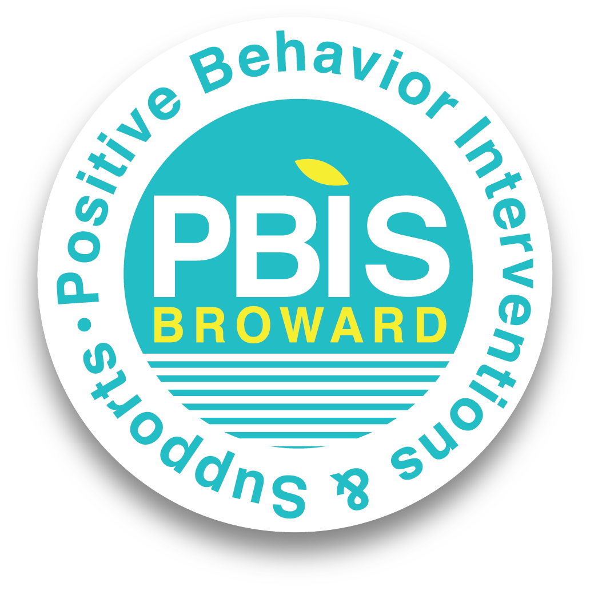

Schoolwide Positive Behavior Plan (SPBP)
Broward County Public Schools
SY 2025 – 2026
School Name: | Sawgrass Springs Middle School
School Number: | 3431

Please refer to the SPBP Canvas Resource page to access video tutorials, guidance, and resources for completing the 2025-2026 SPBP template.
CRITICAL ELEMENT # 1: Active Team with Administrative Participation

1A. Integrated MTSS School-Leadership Team Members
Title | First and Last Name | Title | First and Last Name
1. Administrator | Eric Reeves | 7. Security Specialist/ Campus Monitor | James Colon
2. Point of Contact | Shawn Sealy | 8. Social Worker | Keisha Watson
3. BTU Representative | Emily Riedmayer | 9. School Nurse | Jesika Van Welie
4. Parent/Community Representative | Eric Waters | 10. Attendance Manager | Ada Lopez
5. Student Representative | Sarah Pena | 11. Life Skills & Wellness Liaison | Kimberly Smith
6. School Counselor | Debra Clark | 12. Resiliency Liaison | Deanna Waters
*Optional Team Member(s): Family Therapist, Grade Level/Content Area Representatives, Clerical, Custodial, Food/Nutrition

1B. Schedule of quarterly team meetings.
Meeting Objectives:
1. Progress monitor the action steps indicated in Critical Element #9.
2. Collect & analyze student outcome data using the 4 Step Problem Solving Process.

Quarter | PBIS Data Meeting Dates | PBIS Data Meeting Times |  | Faculty and Staff Data Communication/Presentation Dates
1st | 8/6/2025 | 3:50pm – 4:50pm |  | 8/9/2025
2nd | 11/19/2025 | 3:50pm – 4:50pm |  | 11/21/2025
3rd | 2/11/2026 | 3:50pm – 4:50pm |  | 2/13/2026
4th | 5/13/2026 | 3:50pm – 4:50pm |  | 5/15/2026

CRITICAL ELEMENT # 2: Faculty & Stakeholder Commitment

2. Team communication/presentation of new SPBP to staff and stakeholders
Action Steps: | Dates
Present the 2025-26 SPBP to staff (prior to April 30, 2025) | 4/24/2025
Hold a faculty vote on the new SPBP (prior to April 30, 2025) | 4/29/2025
Provide training to faculty and staff (prior to September 30, 2025) | 8/9/2025
Present the 2025-26 SPBP to family and community stakeholders (prior to September 30, 2025) | 9/4/2025

CRITICAL ELEMENT # 3: Data Collection and Analysis

3A. Core Effectiveness: Use current 2024-2025 school year behavior data as listed in Focus.
- Review your referral data YTD in Focus – Discipline Reports – Students with Referrals.
- Complete the yellow highlighted cells.
- Auto-calculate the “% of Total Population” by clicking on each “!Zero Divide” in the cells and pressing “Fn + F9”.
- Determine if the core is effective in all three areas.

TOTAL Population: |  | % of Total Population | Core Effectiveness
# Referrals: | # of Students:
- 0 - 1 referrals | 88 | 9% | Are your 0 – 1 referral > 80%? | ☒Yes ☐No
II. 2 - 5 referrals  (at risk students) | 41 | 4% | Are your 2 - 5 referrals <15%? | ☒Yes ☐No
III. > 5 referrals  (high-risk students) | 10 | 1% | Are your >5 referrals <5%? | ☒Yes ☐No

3B. Core Effectiveness Action Steps:

If you answered “Yes” to I, II, and III above, then your core is effective.  Based upon table 8A, is your core effective? | ☒Yes ☐No
Answer either (a) or (b):
(a) If your core is effective, then identify action steps your school leadership team should continue to take for early identification of at risk or high-risk students.
(b) If you answered “No” to at least one of the items above (I, II, or III) then indicate the supports and interventions and action steps your school leadership team will implement at the beginning of the next school year to improve core strength:
Core Effectiveness Action Steps: (3-4 detailed steps)
1. Meet monthly to evaluate the frequency of all infractions
2. Utilize incentive programs to evaluate behavior/outcomes as a deterrent to negative actions.
3. Monthly awards to students
4.

3C. Disproportionality is often measured with the relative risk statistic calculation (Relative Risk Ratio = RRR), a measure that indicates the probability of a certain event (e.g., referrals) for one subgroup when compared to all other subgroups.

Relative Risk Ratio calculations are coming soon with the Focus Data System migration.

3D. Disproportionality Action Steps:

What activities/initiatives/programs will your school leadership team implement to prevent disproportionate discipline outcomes within sub group populations (race, SWD, ELL)?
Disproportionality Action Steps: (3-4 detailed steps)
1. Evaluate the frequency of infractions by sub-groups.
2. Targeted activities/surveys for sub-groups to mitigate infractions.
3. Monthly awards to students within sub-groups
4.

CRITICAL ELEMENT # 4: Schoolwide Expectations & Location-based Rules

4A. Top five behavior incidents: Use current 2024-2025 school year behavior data as listed in Focus.
- Review your referral data YTD in Focus – Discipline – Category Breakdown – Highest Discipline Code.
- Complete the chart by identifying the top five behavior incidents and the number of incidents for each type.
- Complete the yellow highlighted cells.
- Auto-calculate the total # of referrals by clicking on “0” and pressing “Fn + F9” together.
Top 5 Behavior Incidents  Current Year 2024-2025 | # Incidents
1. Unruly/Disruptive Behavior | 52
2. Disobedience/Insubordination | 24
3. Disruptive/Unruly Play | 20
4. Battery(low level) | 19
5. Class Cut/Skipping | 18
TOTAL | 133

4B. School-wide expectations are 3 – 5 positive characteristics (not behaviors) that counteract the top school-wide misbehaviors in section 3A. ALL people on campus are expected to model these expectations.

Schoolwide Expectations
1. Accountability
2. Cultivating Character
3. Teamwork – makes the school, work
4.
5.

4C. Top three school-wide locations: Use current 2024-2025 school year behavior data as listed in Focus.
- Review your referral data YTD in Focus – Discipline – Category Breakdown – Location.
- Complete the chart by identifying the top three schoolwide locations, excluding classroom and the number of incidents for each location.

Top 3 Locations, excluding Classroom:
School Location(s) | # Incidents
1. School Grounds | 51
2. Cafeteria | 34
3. Hallway | 30
4. Restrooms | 15

4D. Expectations and Rules Chart for common areas of school campus:
This chart is posted in all classrooms and used to teach students during behavior lessons.

Schoolwide Expectations and Location-based Rules |  |  |  | Completed by each teacher:
Schoolwide  EXPECTATIONS | Hallway Rules | Cafeteria Rules | Restrooms | Classroom Rules
Accountability | 1. Have your ID badge visible at all times  2. Keep hands and feet to yourself | 1. Keep all food items on your tray  2. Stay seated in assigned area | 1. Provide personal space  2. No inappropriate language or vandalism
Cultivating Character | 1. Follow adult directives  2. Walk directly to class.  3. Speak respectfully to everyone | 1. Raise your hand to get the attention of an attendant/adult  2. Be respectful to everyone at your table | 1. Follow directions the first time given  2. Report any bullying or disruptive behavior
Teamwork - makes school, work! | 1. Walk on the right side of the hallway  2. Go directly to your destination | 1. Follow all directions given by the cafe monitors/adults  2. Clean your eating space and pick up trash around your area | 1. Clear this area directly after use.  2. Return to class immediately once finished.

CRITICAL ELEMENT #5: Teaching Behavior

5A. At least one lesson plan for each schoolwide expectation above is distributed to instructional staff during pre-planning week and are maintained in the SPBP Binder.

Dates when the schoolwide expectations lesson plans are taught by instructional staff and noted in lesson plans:
 | Date(s) | Time: | Location(s):
Start of School Year | 8/4/2025 | 9:30am -10:30am | Media center
After Winter Break | 1/8/2026 | 9:30am – 10:30am | Media center
After Spring Break | 3/13/2026 | 9:30am -10:30am | Media center

5B. At least one Rules Lesson Plan for each common location is distributed to instructional staff during pre-planning. This is aligned to the Schoolwide Expectation/Location-based Rules chart in section 4D. Location-based rules should be taught and reinforced in the context of the location in the beginning of the year, after long breaks, and throughout the year as necessary.

Dates when the rules lesson plans for common locations are taught by instructional staff and noted in lesson plans:
Common Location | Hallway Rules | Cafeteria Rules | Restroom
Lesson Plan Dates
Start of School Year | 8/6/2025 | 8/6/2025 | 8/6/2025
After Winter Break | 1/8/2026 | 1/8/2026 | 1/8/2026
After Spring Break | 3/13/2026 | 3/13/2026 | 3/13/2026

5C. Prevention programs and other schoolwide student support initiatives can be used to proactively teach positive behavior and prosocial skills. Use this chart to plan for how you will use District supported programs and initiatives to promote positive behavior on campus.

Program/Initiative | Plan Details
 | When will it be taught? | Who will teach it? | How will it be implemented?  2-3 sentences | How will it be monitored for effectiveness?
Resiliency Curriculum  Click to enter “other” | Monthly (1st Week) | Mr. Sealy will facilitate the teaching. | Faculty and staff would be notified by administration. Teachers will be trained via departmental PLCs. | Through the Resiliency curriculum
Character Education  Click to enter “other” | Monthly (3rd Week) | Through the Resiliency curriculum | Faculty and staff would be notified by administration. Teachers will be trained via departmental PLCs. | Ensure student respond to survey questions

CRITICAL ELEMENT # 6: Recognition Programs

6A. The schoolwide recognition system focuses on reinforcing schoolwide expectations OR a specific location where referrals often occur. The recognition should be used to encourage, acknowledge, and reinforce students to exhibit positive behaviors.

Identified Schoolwide Expectation OR Specific Location: Click here to enter Expectation OR Location

4 Step Problem Solving Process | Plan Details
- Problem Identification: Review your behavior data to identify one school-wide problem. What problem did you identify?  (use numerical data) | Data used: Big 5 Data - Quarter 3  Problem Identification Statement: Out of the top five major behavioral infractions, Disruptive (unruly behavior accounted for 37% of the offenses.
2. Problem Analysis: Why do you think this problem is occurring?  What is your goal?  (create a SMART goal statement with numerical data) | Hypothesis: Students deem consequences issued for repeated offences as a non-deterrent.  SMART Goal Statement: By the end of the second quarter, 95% of the students (across grade levels) would
3. Intervention Design: Describe how you will implement a positive reward program/system to decrease this problem. | Type of Program/System: Economic simulation system  Description of Program/System: I will use a ‘gator bucks’ system to reward positive behavior. Teachers who observe students inside/outside the classroom can issue students with a gator buck which students can redeem for items of their choice.
4. Evaluation:  A. Implementation fidelity | How will you monitor the fidelity (consistency and effectiveness) of the staff’s implementation of the reward program/system? (2-3 sentences)  Teachers can document on a sheet which identifies the name and the tickets issued to each student identified.
B. Student outcome monitoring (use numerical data) | How will you know if the reward program/system is positively impacting students? What measurable data will you use to determine “success”? (2-3 sentences)  The three common infractions identified as concerns will be reduced based on the quarterly Big 5 data records.

6B. Character Education is an educational and award program utilized to teach and recognize students who display positive character traits each month. Please refer to the BCPS website for lesson plans, videos and additional resources to support this recognition program at your school.

Monthly Character Traits | Plan Details  How will you recognize Kids of Character each month? (2-3 sentences)
- September: Cooperation  - October: Responsibility  - November: Citizenship  - December: Kindness  - January: Respect  - February: Honesty  - March: Self-Control  - April: Tolerance | - Outstanding students will be chosen by teachers per class.  - Students will be acknowledged on a weekly basis and rewarded with incentives.

CRITICAL ELEMENT #7: Effective Discipline Procedures
You can choose to use the flow chart below or create your own. This flow chart is posted in all classrooms and used to teach students during behavior lessons.
Positively reinforce change in behavior

Did the behavior improve?
Positively reinforce change in behavior
Apply Administrative Consequence(s): Office Discipline Referral (ODR)
CPST Referral
Positively reinforce change in behavior
Apply minor consequence(s):
Private student conference
Discussion
Proximity control
Encouragement Gentle verbal reprimand
Did the behavior improve?
Apply moderate consequence(s):
Positive Practice
Time Out/Owed
Loss of privilege
Family contact
Utilize Tier 1 PBIS strategies to prevent misbehaviors.

Tier 1 Strategies include, but are not limited to:
Effective classroom structure Precorrection
Preferential seating/seat change
Remove distractions
Personal schedule/organization
Reteach expectations and rules
Redirection
Prompts, cues, and reminders
Think time/cool down area
Consistent reward system
Modify academic assignments
Provide choices

If you observe misbehavior, intervene.
Is it a Staff Managed or Office Managed Misbehavior?
Redirect/prompt (verbal or gestural)
Review class rules/teach expected behavior
Did the behavior improve?
Staff:
Submit an office discipline referral (ODR) using report style writing
(non-judgmental, observable, and measurable language)
Administrator:
Review, investigate and apply consequence according to policy
Contact family to communicate incident and consequence
Follow up with teacher/feedback/support
Crises Events:
In need of immediate assistance
Potentially unsafe environment
Suspision of criminal behavior
Contact front office/administration immediately
Follow safety team protocol

Staff Managed Misbehaviors | Office Managed Misbehaviors
Note: The behaviors provided are examples, not an exhausted list of misbehaviors.
Inappropriate language  - name calling  - use of profanity | Inappropriate language  - racial slurs or taunting  - profanity directed at a staff member
Disrespect  - talking back  - physical gestures | Harassment  - bullying  - threat or intimidation
Defiance  - work refusal  - head down on desk/sleeping  - not following directions | Defiance  - leaving classroom, assigned area, or school grounds without permission  - forgery/plagiarism
Disruptive  - tattling/false information  - talking out of turn  - calling out  distracting others | Disruptive  - inciting others to disrupt teacher  - chronic classroom disruption: more than 3 times within 30 minutes
Physical Contact  - touching others, pushing/shoving (no injuries)  - mutual horseplay | Physical Contact  - touching others (hitting, kicking, biting) with intent to do harm  - petty theft
Violation of classroom or location-specific rules | Violation of the Code of Student Conduct
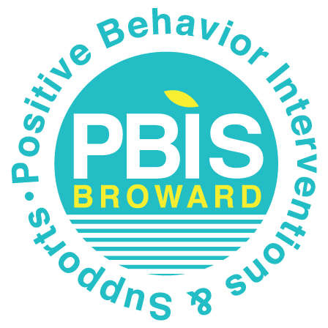
CRITICAL ELEMENT # 8: Classroom Management Systems

8A. Evidence-based Tier 1 classroom management system:

Which evidence-based system(s) are you using? | Provide 3-4 measurable and observable action steps the team will take to help educators improve their classroom management system. (3-4 detailed steps)
☐ CHAMPS  ☐ Positive Behavior Interventions and Supports and the Classroom  https://fl-pda.org/#/category/26  ☐ Other: Click here to enter name of system. | 1. During the week of orientation, teachers will receive training on CHAMPS classroom management system  2. Each grade level admin will do ad hoc classroom walkthroughs during the first four weeks of quarter one, to verify that CHAMPS is being implemented with fidelity in classrooms.  3. By the completion of first quarter, 100% of the teachers will implement/integrate CHAMPS classroom management system  4.

8B. The administration reviews and analyzes the fidelity of staff implementation of Tier 1 classroom management systems across teachers using:


☐ CHAMPs 7 Up Checklist
☒ Classroom Snapshot (Classroom Management Assessment)
☒ PBIS Classroom Assistance Tool (CAT)
☐ Other (specify):

8C. Percentage of classroom referrals: Use current 2024-2025 school year behavior data as listed in Focus.
(a) Review your classroom data YTD in Focus – Discipline – Category Breakdown – Location.
(b) Complete the yellow highlighted cells.
(c) Auto-calculate the % of referrals in the classroom by clicking on “!Zero Divide” in the next cell and pressing “Fn + F9” together.

Total number of discipline referrals from classrooms: | 166
Total number of other school-wide discipline referrals (not including classrooms): | 147
% of referrals in the classroom: | 53%
Do more than 40% of your referrals come from the classroom? | ☒ Yes ☐ No
If >40% of discipline referrals come from the classroom, it suggests Tier 1 classroom management implementation may need to be strengthened school wide.

Critical Elements # 9: SPBP Implementation Planning
RED Font = Action Steps for all schools in Broward County
GREY Font = Best Practices for all schools in Broward County
TEAL Font = Resources available at https://browardschools.instructure.com/enroll/PWF673
Implementation Action Plan
Month | Action Steps  ☒ check off Action Step when completed
Current | ☐ Create an SPBP binder or portfolio to retain (for 2 years) hard copies of: your SPBPs, Action Plans, staff PBIS  professional development attendance, stakeholder training attendance, quarterly meeting agendas, quarterly staff  behavior presentations, voting attendance and outcome, Expectations lesson plans and Rules lesson plans
Pre-Planning | ☐ Print up your SPBP and Feedback form BCPS Central  ☐ Provide SPBP presentation to all staff during Pre-Planning  ☐ Disseminate the current SPBP (hard copy or electronically) to all staff and stakeholders  ☐ Market and post School-wide Expectations and Location-specific Rules  ☐ Identify your district PBIS Specialist  (Contact amber.jennings@browardschools.com for more information if you are unsure)  ☐ Ensure schedule of quarterly meeting dates for entire year as indicated in the SPBP (indicated in yellow)
August  1st Quarter Team Meeting | ☐ Determine any needed team training, such as: 4 Step Problem Solving Process series, PBIS 10  Critical Elements, Data Collection, etc.  ☐ Review previous year’s SPBP and feedback form; make necessary modifications  ☐ Review previous year’s data (Use Tier 1 Agenda and Quarter Big 5 Data template on PBIS Canvas page)  ☐ Verify and implement teaching schedule for Expectations and Rules behavior lesson plans  ☐ Implement the Reward System for all students as indicated in the SPBP  ☐ Ensure the Discipline Flow Chart is distributed to all staff and is being used as written  ☐ Present implementation data, behavior data, team activities and SPBP progress to entire staff  ☐ Ensure all teachers are using an evidence-based classroom management plan, such as CHAMPS  ☐ Confirm next quarterly PBIS team meeting date and time
September | ☐ Provide SPBP stakeholder presentation by September 30th  ☐ Ensure instructional staff know how to document Tier 1 Supplemental Strategies for behavior  ☐ Check for staff and teacher understanding of PBIS - provide “PBIS 101” training as a resource  Brainshark available at: http://www.brainshark.com/browardschools/PBIS101
October  2nd Quarter Team Meeting | ☐ Review previous quarter’s data. (Use Tier 1 Agenda and Quarter Big 5 Data template on PBIS Canvas page)  ☐ Present implementation data, behavior data, team activities, and SPBP progress to entire staff  ☐ Ensure Core Effectiveness Action Steps are being implemented as written  ☐ Complete Quarterly Big 5 Data Template and submit to your PBIS Administrator  ☐ Confirm next quarterly PBIS team meeting date and time
November | ☐ Review/revise lesson plans as indicated by previous quarter behavior data  ☐ Ensure that the Student Outcome Monitoring Action Steps are being implemented as written
January  3rd Quarter Team Meeting | ☐ Staff to re-teach Expectations and Rules after winter break  ☐ Review previous quarter’s data. (Use Tier 1 Agenda and Quarter Big 5 Data template on PBIS Canvas page)  ☐ Present implementation data, behavior data, team activities, and SPBP progress to entire staff  ☐ Complete Quarterly Big 5 Data Template and submit to your PBIS Administrator  ☐ Confirm next quarterly PBIS team meeting date and time
February | ☐ Check on recently hired staff for PBIS understanding - provide “PBIS 101” Brainshark resource  ☐ Utilize the Stakeholder SPBP Forms Survey to solicit input for planning next year’s SPBP (optional)
March  4th Quarter Team Meeting | ☐ Ensure progress towards completion and submission of next year’s SPBP  ☐ Staff to re-teach Expectations and Rules after spring break  ☐ Review previous quarter’s data. (Use Tier 1 Agenda and Quarter Big 5 Data template on PBIS Canvas page)  ☐ Present implementation data, behavior data, team activities, and SPBP progress to entire staff  ☐ Complete Quarterly Big 5 Data Template and submit to your PBIS Administrator
April | ☐ Provide staff presentation and faculty vote on new SPBP for next year  ☐ Submit your SPBP in BCPS Central by April 30th. Use this new SPBP in the next school year  ☐ Continue implementing your current SPBP through the end of the current school year

CRITICAL ELEMENT # 10: Evaluation
10A. Staff Implementation of the Schoolwide Positive Behavior Plan: review goals, evaluate implementation, and create 2 action steps to review in quarterly PBIS meetings.
“Are staff implementing the SPBP with fidelity? If not, how will you address this area?”
STAFF Implementation Monitoring
Staff Implementation Goal | Quarterly Team Review:  Implemented with fidelity? | If you answered No, enter 2 action steps your school will take to move towards this goal by the next PBIS meeting.
100% of hallways, front office, cafeteria, and other public areas all have school-wide expectations and location-specific rules posted. | ☒Yes ☐No | By Click here to enter a date,  1.  2.
100% of instructional staff has delivered expectations and rules lesson plans as written and when indicated. | ☒Yes ☐No | By Click here to enter a date,  1.  2.
100% of staff members are oriented to the Discipline Flow Chart. It is used consistently by 100% instructional staff, behavioral support, and administrators. | ☒Yes ☐No | By Click here to enter a date,  1.  2.
A recognition system is implemented by 100% staff for all students. | ☒Yes ☐No | By Click here to enter a date,  1.  2.

10B. The SPBP is successful in positively impacting students: review behavior data and create a SMART goal. Evaluate implementation and create action steps to review in quarterly PBIS meeting.
“If staff are implementing the SPBP consistently and effectively, is it positively impacting students? How will you know?”
SMART Criteria:
S | Specific | Concrete, detailed, focused, and well defined. Results-focused and action-orientated.
M | Measurable | The measurement sources (data) are defined numerically in order to track progress towards the objective.
A | Attainable | Objectives are achievable in the near future to maintain motivation.
R | Realistic | Staff have the resources to achieve the objective- time, personnel, materials, etc.
T | Time-bound | Agreed-on time frames create the necessary urgency and prompt action.

STUDENT Outcome Monitoring
Student Outcome Data | Complete the SMART goal to determine “successful” student outcomes (use numerical data) | List 2 action steps your team will take to ensure this goal is monitored and meets or exceeds the SMART goal.
Select an item  Choose one ODR area of focus | By 06/30/2026 the number of disruptive and unruly behavior incidents will show a 20% decrease from 79 to 63 as measured by ODRs in BASIS. in Focus. | 1. Increase supervision in the hallways, strategically placing teachers and security personnel to move student traffic through transition between classes  2. Utilize Broward County Public School Code of Conduct Book & Discipline Matrix to minimize infractions.

SPBP Submission
- Upload completed SPBP (as PDF) into BCPS Central in the School Improvement Plan.
- Complete PBIS Point of Contact form.

