
Coral Springs High School
Schoolwide Literacy Plan 2025-2026
Dwayne K. Dixon, Principal
Patricia Bolinger, Assistant Principal
Goals:
- CSHS will initiate purposeful opportunities for students to read , interact and respond to grade level text.
- CSHS will produce independent learners and thinkers through effective use of the gradual release of responsibility teaching model.
- CSHS will utilize multiple sources of data to inform instruction, differentiation and intervention.
Standards:
ELA. K.12.EE.2.1 Read and comprehend grade-level complex texts proficiently.
ELA. K.12.EE.1.1 Cite evidence to explain and justify reasoning.
ELA.K.12. C.3.1 Follow the rules of standard English grammar, punctuation, capitalization, and spelling appropriate to grade level.
ELA.910. V.1.3 Apply knowledge of context clues, figurative language, word relationships, reference materials, and/or background knowledge to determine the connotative and denotative meaning of words and phrases, appropriate to grade level.
Leveraging Core ELA instruction

To improve teaching and learning by providing high-quality explicit instruction, the literacy departments will follow the curriculum pathways provided by the district to promote targeted individual classroom instruction. Teachers will rely on the gradual release of responsibility model as their mode of instruction. Furthermore, within the school’s Professional Learning Communities (PLCs), English and Reading teachers will analyze HMH’s NWEA Map Growth assessments and HMH’s Read 180/The Code assessments to realign instructional delivery for targeted standards. Currently, all HMH NWEA MAP Growth assessments will be administered three times a year on a digital platform in coordination with the district provided assessment windows. Additionally, CFA’s will be given biweekly and discussed within PLC meetings. The ELA teacher's analysis of the data will result in reinforcement of learning opportunities through small group instruction during the instructional day, and enrichment.

Data Informed Decisions
Reading is a continued area of focus for improving student achievement. A strategic plan to impact literacy performance by developing student's ability to read and comprehend complex literary and informational texts independently and proficiently is a state and school goal. As such, we utilized the data from the Spring Florida Assessment of Student Thinking to determine our literacy goals for the 2025-2026 school year.

FAST (Florida Assessment for Student Thinking)

According to our 9th and 10th grade FAST data 57% of our 9th students exemplified reading proficiency therefore, considering the B.E.S.T. standards and FAST examination, our proficiency goal for the incoming 9th and 10th grade students is to have 60% of our students meet reading proficiency by the April/May 2026 FAST PM3.
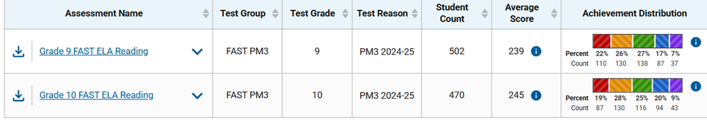
The data also informs us that the category with the least amount of growth was Reading Prose and Poetry, necessitating a greater emphasis on exposing students to poetry.

ESOL
ENGLISH LANGUAGE LEARNERS (Achievement level)
Schoolwide
Grade 9 | Grade 10
   | %
  DECREASE | 6.45%
  INCREASE | 45.16%
  NO CHANGE | 48.39%
  Grand Total | 100.00%
   | %
  DECREASE | 12.00%
  INCREASE | 46.00%
  NO CHANGE | 42.00%
  Grand Total | 100.00%

The assessment data indicates a striking similarity between ELL students who increased and those that had no change. As a result, it is fair to presume students' response to instruction is seemingly poor.

Progress Monitoring
HMH and FAST assessments will be administered 3x a year in English and Reading courses. The curriculum, instruction, and assessment data must be compiled and reviewed by the literacy coach. CFA’s (HMH selection tests) are given biweekly and analyzed. Using the District C.A.R.E (Curriculum, Assessment, Remediation, Enrichment) Cycle as the guideline, the data collected is used to:

Remediate: Peer tutoring, Remediation, student data chats, reteaching, additional practice, supplementary instruction, push ins/ pull outs.
Enrich: Student-mentor roles, project-based learning, extension activities, instructional technology such as NewsELA, Nearpod, and CPALMS.

Students are placed in an intervention in accordance with the district's intensive reading decision tree chart and use the adopted curriculum. The core curriculum provides modeled reading and writing, shared reading and writing, guided reading and writing, independent reading, and writing. Into Literature boats a host of scaffolding and differentiation tools (level up tutorials, text sketch, etc.) Additionally, both in school and after school tutoring and pullouts seek to accommodate students in need of additional support.

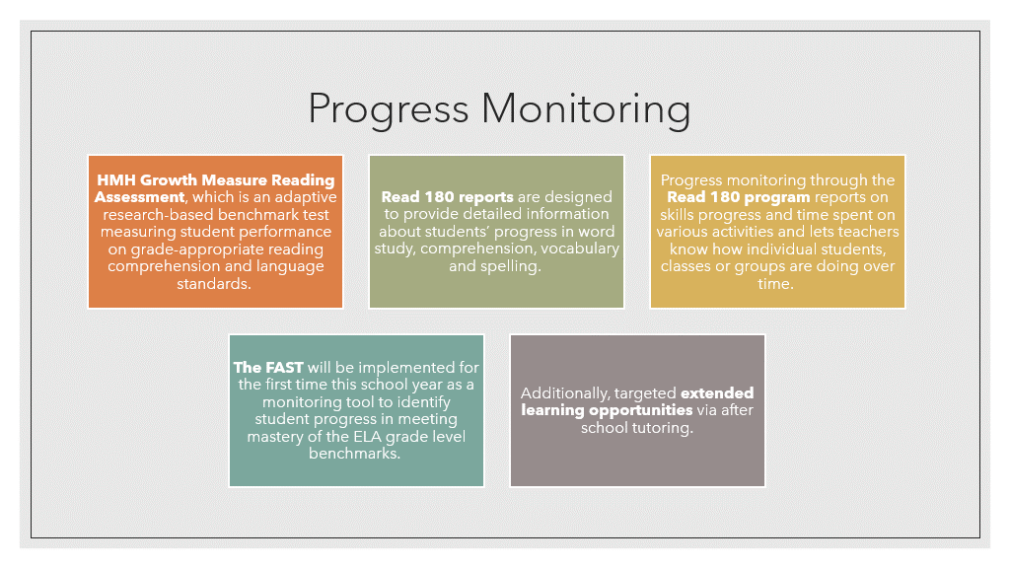
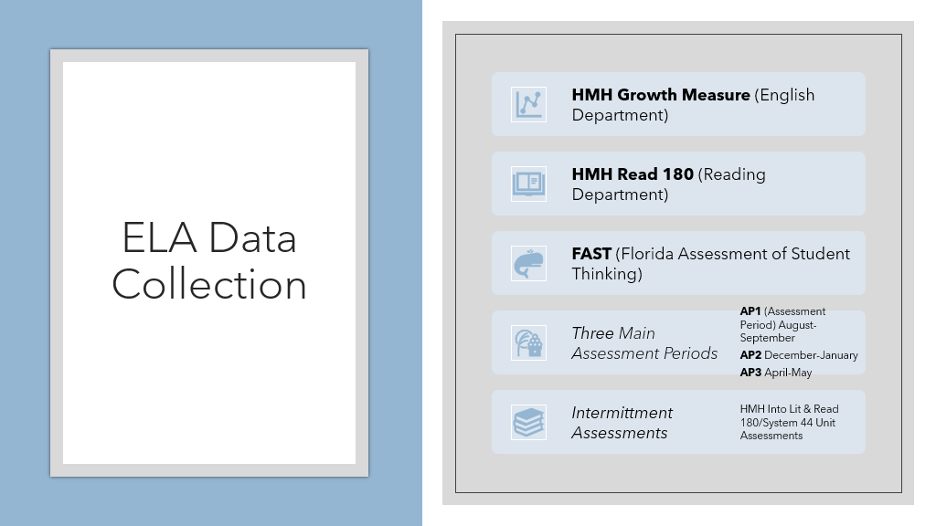

Interdisciplinary Focus
To support our current literacy initiatives, we are committed to taking an interdisciplinary approach to literacy strategies. According to last year’s data, more than 50% of our students are at/near proficiency with reading informational text and vocabulary. Therefore, within each of our content areas, we have decided to focus on specific reading processes and implementation of intentional written language strategies. We will adopt the gradual release of responsibility model as our preferred mode of instruction. Also, we will ensure students engage with meaningful text daily through purposeful warm-up activities.
- Math – Focus on understanding word problems (as it applies to the math curriculum), reasoning, and evaluating the meaning of each word and symbol using C.U.B.E.S strategy.
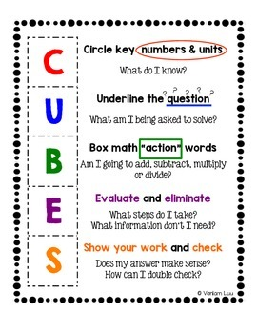

- Science – Focus on reading to understand scientific information and how to explain it using various forms of representations (interpret and transform information from diagrams, photos, equations, etc.).
- Social Studies – Focus on synthesizing and analyzing multiple perspectives and interpretations of history and historical documents and claims.
- Language Arts/Reading – Focus on learning the language of literacy interpretation, seeing patterns within and across texts and contexts, and helping students improve their overall Reading/English language achievement level.
- ALL Content Areas – As part of our School-Wide Literacy Plan, all teachers, in all content areas will make the following a part of their daily instructional practices:

    - Ensure that you are relying on the gradual release of responsibility model as your method of instruction.
    - Ensure that students are applying pre, during and post reading strategies (see graphic below)
    - Ensure that students are completing purposeful do now/ warm up activities that require them to interact with authentic text, respond to an extended response question prompt, and format response using R.A.C.E.S (see below)
    - Ensure that students are providing the opportunity to interact with meaningful text
    - Implement our “Literacy Lift” as described (see below)

Literacy Lift
Supporting and embracing literacy in every classroom the Colt Country way #ColtsUnited

 | Who? | What? | When? | Where? | Why? | How?
Quarter 1 | All subject areas | #ColtsRead  Students will stop, drop and read a text of their choice during the allotted time and complete an entry using the provided reading log. | 10 minutes  1x per week  First class meeting of the week  Period 2 | Classroom | Reading is critically important for students because it builds a foundation for lifelong learning and success in all subject areas. Reading: Develops Language and Vocabulary Skills,  Improves Comprehension and Critical Thinking,  Encourages Focus and Concentration. | Teachers may choose to allow students to access reading material digitally using the SORA app, via your classroom library, scheduled book check out, OR consult with media specialist to request a curated book collection.  Teachers have the autonomy to assign a genre/collection related to subject area OR allow students to choose freely.  Teachers are encouraged to elicit verbal feedback from students regarding what they have read in addition to their completion of the log provided.  At the close of the quarter, teachers will submit reading logs to their respective administrator- DUE 10/13
Quarter 2 | All subject areas | Vocabulary Vault  Students will select a content specific vocabulary word from the list provided and complete a vocabulary word map. | 10 minutes  1x per week  First class meeting of the week  Period 6 | Classroom | Vocabulary acquisition is critically important in the classroom because it directly affects a student’s ability to understand, communicate, and succeed academically across all subjects. Understanding vocabulary improves reading comprehension and supports learning complex content. | Teachers will share provided word lists with students and require them to complete a vocabulary word map.  Teachers have the autonomy to assign a specific word OR allow students to choose freely.  Word lists will be comprised based on current area of focus.  At the close of the quarter, teachers will submit completed word maps to their respective administrator- DUE 1/5
Quarter 3 | All subject  areas | #ColtsComprehend  Students will read and respond to content specific text in various forms (multiple choice, extended response using RACES, DBQ’s, etc.) | 10 minutes  1x per week  First class meeting of the week  Period 3 | Classroom | It is important for students to read and respond to text because it helps them become active, thoughtful, and skilled learners. Reading and responding to text builds comprehension by allowing students the opportunity to make sense of what the text is saying. | Teachers will be provided with content specific texts and tasks to share with students.  Students will read and respond as directed  At the close of the quarter, teachers will collect and submit completed responses to their respective administrator. -DUE 3/13
Quarter 4 | All subject areas | #ColtsComprehend  Students will read and respond to content specific text in various forms (multiple choice, extended response using RACES, DBQ’s, etc.) | 10 minutes  1x per week  First class meeting of the week  Period 7 | Classroom | It is important for students to read and respond to text because it helps them become active, thoughtful, and skilled learners. Reading and responding to text builds comprehension by allowing students the opportunity to make sense of what the text is saying. | Teachers will be provided with content-specific texts and tasks to share with students.  Students will read and respond as directed  At the close of the quarter, teachers will collect and submit completed responses to their respective administrator. - DUE 6/4

Reading & Writing Strategy RACE (RESTATE, ANSWER, CITE, EXPLAIN)

Every Student will respond to writing prompts in every class using the R.A.C.E.S format. The R.A.C.E.S format will be taught in Reading and English/Language Arts Classes. Students will be expected to implement this writing strategy in all content areas.
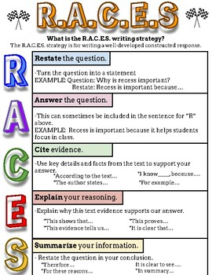

    - Consistent implementation of processes and practices as outlined on the CSHS “This is how we do it” Literacy Poster (see below)
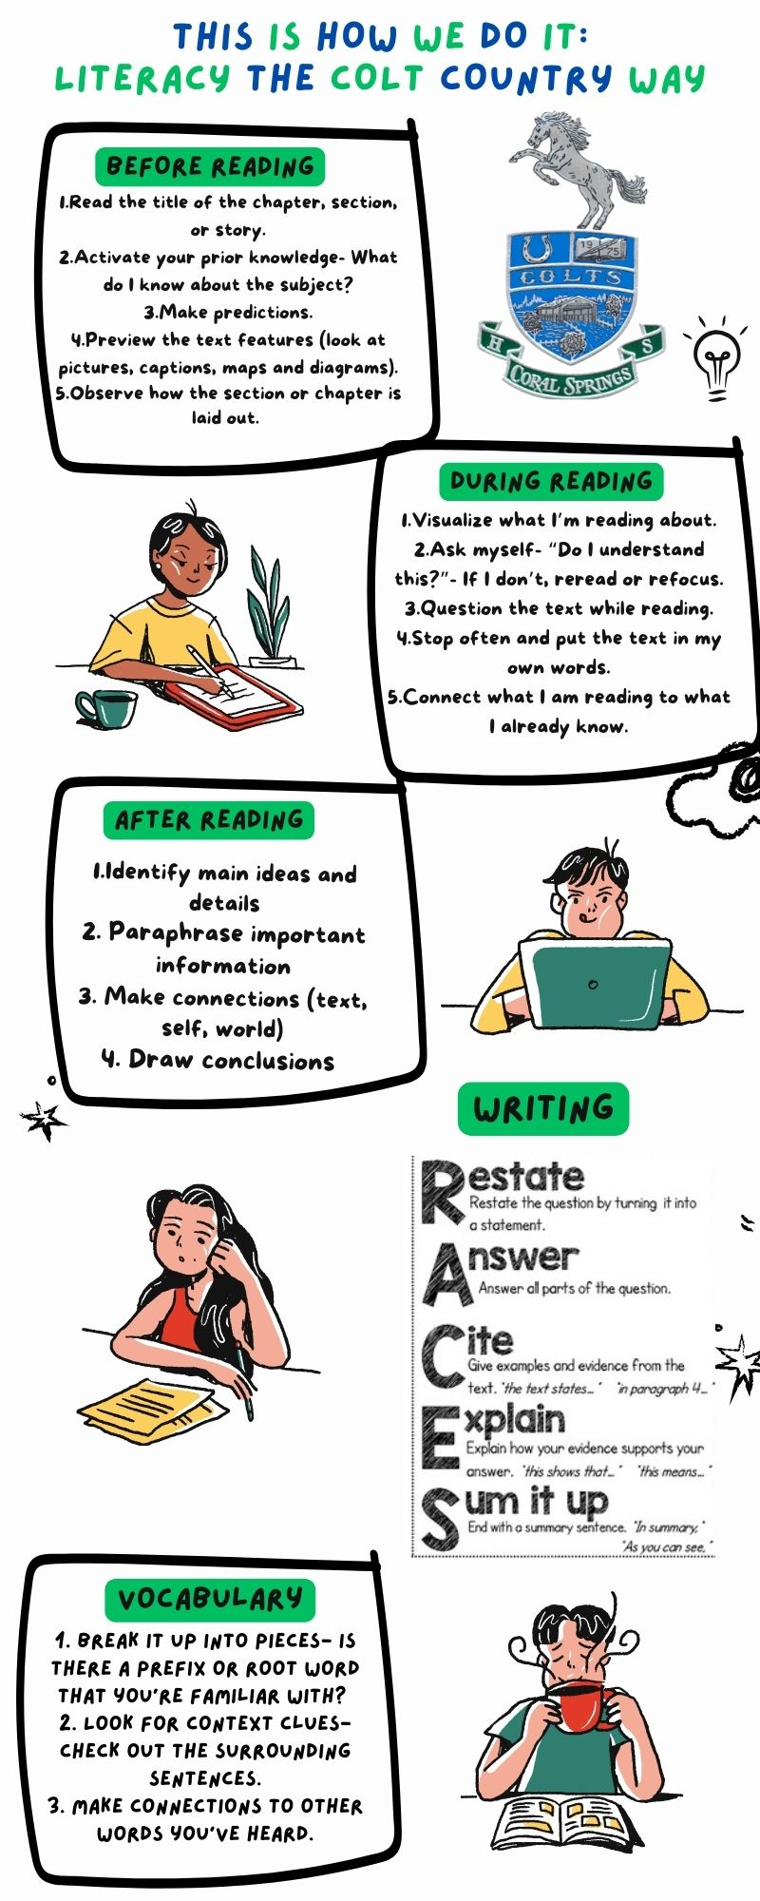

Literacy Support Team

K-12 Comprehensive Reading Plan – Literacy Leadership Team/CPS Team
Name of School |  | Coral Springs High School
Principal’s Name |  | Dwayne Dixon
Action Steps |  | Collaborators |  | Title | Timeline
Teachers will implement consistent Gradual Release Model (“I Do, We Do, & You Do”) best practices that target students’ needs.  Literacy coach will provide professional development that will assist teachers with Gradual Release Model and grouping and center rotations. |  | Patricia Bolinger  Brittany Smith  Michelle Dulcio  Felice Tzabery |  | AP  Literacy Coach  Department Chair(s) | August 2025 and ongoing
Teachers will utilize B.E.S.T writing standards and grade level specific rubrics and model the writing process. |  | Patricia Bolinger  Brittany Smith  Michelle Dulcio  Felice Tzabery |  | AP  Literacy Coach  Department Chair(s) | August 2025 and ongoing
Reference K-12 reading plan to use evidence-based instructional and supplemental materials with significant effect on improving student achievement. |  | Patricia Bolinger  Brittany Smith  Kristen Rusnak  Cassandra Brice |  | AP  Literacy Coach  ESE Specialist  ESOL Coordinator | August 2025 and ongoing
Ensure that all instruction in foundational reading skills is systematic and explicit and all reading instruction is evidence-based (I Do, We Do & You Do). |  | Patricia Bolinger  Brittany Smith  Kristen Rusnak  Cassandra Brice |  | AP  Literacy Coach  ESE Specialist  ESOL Coordinator | August 2025 and ongoing
Progress Monitor students receiving targeted and supplemental (Tier 2) and intensive reading interventions (Tier 3). (NWEA MAP Growth assessment, FAST PM2) |  | Patricia Bolinger  Brittany Smith  Kristen Rusnak  Cassandra Brice |  | AP  Literacy Coach  ESE Specialist  ESOL Coordinator | August 2025, December 2025
Engage in data chats using reading assessments listed on plan. |  | Patricia Bolinger  Brittany Smith  Michelle Dulcio  Felice Tzabery |  | AP  Literacy Coach  Department Chair(s) | September 2025, and ongoing
Teachers will implement small group instruction that is based on best practices that explicitly targets the Language Comprehension of Scarborough’s Rope and based on formal and informal assessments ( Background Knowledge, Vocabulary, Language Structure, Verbal Reasoning and Literacy Knowledge) |  | Patricia Bolinger  Brittany Smith  Michelle Dulcio  Felice Tzabery |  | AP  Literacy Coach  Department Chair(s) | August 2025 and ongoing
Ensure literacy instruction is incorporated into content areas to build text discussions to deepen understandings by utilizing the Gradual Release Model and center rotations. |  | Dwayne Dixon  Patricia Bolinger  Darius Saunders  Linda Bailey  Beth Winterholler  Keith Roberson  Brittany Smith  ELA: Michelle Dulcio and Felize Tzabery  Science: Jennifer Scivetti  Social Studies: Brittany Dodge  Math: Veronica Conrad |  | Principal  AP  AP  AP  AP  AP  Literacy Coach  Literacy  Department Chairs | September 2025 and Ongoing
Provide and Monitor Differentiated Professional Development opportunities for teachers including Professional Learning Communities and reading instruction. | Dona Maggio  Patricia Bolinger |  | PLC Coordinator  AP |  |  | September 2025 and Ongoing

