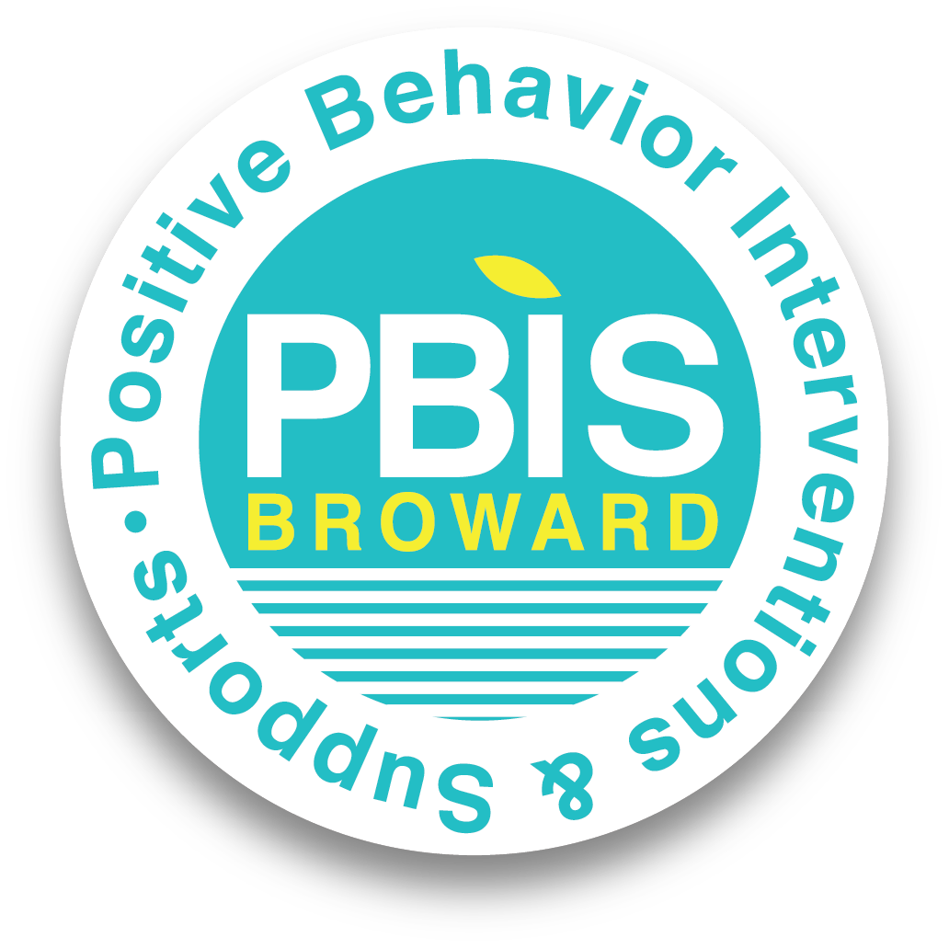

Schoolwide Positive Behavior Plan (SPBP)
Broward County Public Schools
SY 2025 – 2026
School Name: | Floranada Elementary School
School Number: | 0851

Please refer to the SPBP Canvas Resource page to access video tutorials, guidance, and resources for completing the 2025-2026 SPBP template.
CRITICAL ELEMENT # 1: Active Team with Administrative Participation

1A. Integrated MTSS School-Leadership Team Members
Title | First and Last Name | Title | First and Last Name
1. Administrator | Karen Dallas | 7. Security Specialist/ Campus Monitor | Geeta Persaud
2. Point of Contact | Karen Dallas | 8. Social Worker | Lisa McGarry
3. BTU Representative | Lauren Ryan | 9. School Nurse | Leslie Clarke
4. Parent/Community Representative | Stacey Hernandez | 10. Attendance Manager | Renee Ruttenburg
5. Student Representative | Merrick White | 11. Life Skills & Wellness Liaison | Victoria Chery
6. School Counselor | Kristin Barclay | 12. Resiliency Liaison | Jane Doyle
*Optional Team Member(s): Family Therapist, Grade Level/Content Area Representatives, Clerical, Custodial, Food/Nutrition

1B. Schedule of quarterly team meetings.
Meeting Objectives:
1. Progress monitor the action steps indicated in Critical Element #9.
2. Collect & analyze student outcome data using the 4 Step Problem Solving Process.

Quarter | PBIS Data Meeting Dates | PBIS Data Meeting Times |  | Faculty and Staff Data Communication/Presentation Dates
1st | 9/2/2025 | 2:15 PM |  | 9/8/2025
2nd | 12/2/2025 | 2:15 PM |  | 12/8/2025
3rd | 2/3/2026 | 2:15 PM |  | 2/9/2026
4th | 5/5/2026 | 2:15 P |  | 5/11/2026

CRITICAL ELEMENT # 2: Faculty & Stakeholder Commitment

2. Team communication/presentation of new SPBP to staff and stakeholders
Action Steps: | Dates
Present the 2025-26 SPBP to staff (prior to April 30, 2025) | 4/18/2025
Hold a faculty vote on the new SPBP (prior to April 30, 2025) | 4/25/2025
Provide training to faculty and staff (prior to September 30, 2025) | 8/6/2025
Present the 2025-26 SPBP to family and community stakeholders (prior to September 30, 2025) | 9/2/2025

CRITICAL ELEMENT # 3: Data Collection and Analysis

3A. Core Effectiveness: Use current 2024-2025 school year behavior data as listed in Focus.
- Review your referral data YTD in Focus – Discipline Reports – Students with Referrals.
- Complete the yellow highlighted cells.
- Auto-calculate the “% of Total Population” by clicking on each “!Zero Divide” in the cells and pressing “Fn + F9”.
- Determine if the core is effective in all three areas.

TOTAL Population: | 714 | % of Total Population | Core Effectiveness
# Referrals: | # of Students: | % of Total Population
- 0 - 1 referrals |  | .014% | Are your 0 – 1 referral > 80%? | ☒Yes ☐No
II. 2 - 5 referrals  (at risk students) | 5 | .007% | Are your 2 - 5 referrals <15%? | ☒Yes ☐No
III. > 5 referrals  (high-risk students) | 4 | .006% | Are your >5 referrals <5%? | ☒Yes ☐No

3B. Core Effectiveness Action Steps:

If you answered “Yes” to I, II, and III above, then your core is effective.  Based upon table 8A, is your core effective? | ☒Yes ☐No
Answer either (a) or (b):
(a) If your core is effective, then identify action steps your school leadership team should continue to take for early identification of at risk or high-risk students.
(b) If you answered “No” to at least one of the items above (I, II, or III) then indicate the supports and interventions and action steps your school leadership team will implement at the beginning of the next school year to improve core strength:
Core Effectiveness Action Steps: (3-4 detailed steps)
1.The leadership team will continue to utilize counseling opportunities with the School Counselors when a student is referred for behavior.
2. The leadership team will continue to use the RTI process to discuss and monitor behavior concerns.
3. The leadership team will continue to communicate with parents regarding student behaviors.
4. The leadership team will implement a mentorship program for high-risk students.

3C. Disproportionality is often measured with the relative risk statistic calculation (Relative Risk Ratio = RRR), a measure that indicates the probability of a certain event (e.g., referrals) for one subgroup when compared to all other subgroups.

Relative Risk Ratio calculations are coming soon with the Focus Data System migration.

3D. Disproportionality Action Steps:

What activities/initiatives/programs will your school leadership team implement to prevent disproportionate discipline outcomes within sub group populations (race, SWD, ELL)?
Disproportionality Action Steps: (3-4 detailed steps)
1. The leadership team will provide strategies and resources, through ESE staff and coaches, to help teachers of students with disabilities deal with challenging behaviors.
2. Work with administrative team, ESE, ESOL, and teachers to analyze discipline data by subgroups on a quarterly basis.
3. Use behavior expectations that are stated positively, taught explicitly, and consistently reinforced across all subgroups recognized utilizing the Falcon Feather.
4. Create opportunities for reflection using the RESET Spot for all subgroups with support from the guidance counselors and administration.

CRITICAL ELEMENT # 4: Schoolwide Expectations & Location-based Rules

4A. Top five behavior incidents: Use current 2024-2025 school year behavior data as listed in Focus.
- Review your referral data YTD in Focus – Discipline – Category Breakdown – Highest Discipline Code.
- Complete the chart by identifying the top five behavior incidents and the number of incidents for each type.
- Complete the yellow highlighted cells.
- Auto-calculate the total # of referrals by clicking on “0” and pressing “Fn + F9” together.
Top 5 Behavior Incidents  Current Year 2024-2025 | # Incidents
- Battery | 18
- Unruly/Disruptive Behavior | 6
- Disobedience/Insubordination | 5
- Insulting/Profane/Obscene Language | 5
- Disruptive/Unruly Play | 4
TOTAL | 38

4B. School-wide expectations are 3 – 5 positive characteristics (not behaviors) that counteract the top school-wide misbehaviors in section 3A. ALL people on campus are expected to model these expectations.

Schoolwide Expectations
- Be Safe
- Be Respectful
- Be Responsible
- Be Kind
- Be Proud to be a Falcon!

4C. Top three school-wide locations: Use current 2024-2025 school year behavior data as listed in Focus.
- Review your referral data YTD in Focus – Discipline – Category Breakdown – Location.
- Complete the chart by identifying the top three schoolwide locations, excluding classroom and the number of incidents for each location.

Top 3 Locations, excluding Classroom:
School Location(s) | # Incidents
1. Cafeteria | 12
2. Hallway | 7
3. Playground | 6

4D. Expectations and Rules Chart for common areas of school campus:
This chart is posted in all classrooms and used to teach students during behavior lessons.

Schoolwide Expectations and Location-based Rules |  |  |  | Completed by each teacher:
Schoolwide  EXPECTATIONS | Hallway Rules | Cafeteria Rules | Playground Rules | Classroom Rules
Be Safe | Keep hands and feet to yourself | Raise your hand to get the attention of an attendant/adult | Keep hands, feet and objects to yourself
Be Respectful | Go directly to your destination | Follow all directions given by the cafe monitors/adults | Participate positively with your peers by sharing and taking turns with the playground toys (balls, jump ropes, sidewalk chalk, etc.)
Be Responsible | Use Level 1 voice in the hallways | Clean your eating space and pick up trash around your area | Line up when the whistle blows
Be Kind | Use a finger wave to say hello | Remain seated | Keep athletic materials on the field
Be Proud to be a Falcon! | Remain in your line | Keep all food items on your tray | Stay safe by keeping off the fences and trees

CRITICAL ELEMENT #5: Teaching Behavior

5A. At least one lesson plan for each schoolwide expectation above is distributed to instructional staff during pre-planning week and are maintained in the SPBP Binder.

Dates when the schoolwide expectations lesson plans are taught by instructional staff and noted in lesson plans:
 | Date(s) | Time: | Location(s):
Start of School Year | 8/4/2025 | 11:00 am | Media Center
After Winter Break | 1/5/2026 | 11:00 am | Media Center
After Spring Break | 4/6/2026 | 11:00 am | Media Center

5B. At least one Rules Lesson Plan for each common location is distributed to instructional staff during pre-planning. This is aligned to the Schoolwide Expectation/Location-based Rules chart in section 4D. Location-based rules should be taught and reinforced in the context of the location at the beginning of the year, after long breaks, and throughout the year as necessary.

Dates when the rules lesson plans for common locations are taught by instructional staff and noted in lesson plans:
Common Location | Hallway Rules | Cafeteria Rules | Select location
Lesson Plan Dates
Start of School Year | 8/13/2025 | 8/13/2025 | 8/13/2025
After Winter Break | 1/6/2026 | 1/6/2026 | 1/6/2026
After Spring Break | 4/7/2026 | 4/7/2026 | 4/7/2026

5C. Prevention programs and other schoolwide student support initiatives can be used to proactively teach positive behavior and prosocial skills. Use this chart to plan how you will use District supported programs and initiatives to promote positive behavior on campus.

Program/Initiative | Plan Details
Program/Initiative | When will it be taught? | Who will teach it? | How will it be implemented?  2-3 sentences | How will it be monitored for effectiveness?
Other  Riding the Waves | School Counselor will schedule during 2025-26 school year | Kristin Barclay, School Counselor | Mrs. Barclay will go to the classrooms to teach the 12 lessons. | Feedback from students and teachers.
Resiliency Curriculum  Mindset Matters | School Counselor will schedule during 2025-26 | Kristin Barclay, School Counselor | Mrs. Barclay will go into 3rd grade classrooms to teach 6 lessons. | Feedback from students and teachers.

CRITICAL ELEMENT # 6: Recognition Programs

6A. The schoolwide recognition system focuses on reinforcing schoolwide expectations OR a specific location where referrals often occur. The recognition should be used to encourage, acknowledge, and reinforce students to exhibit positive behaviors.
Identified Schoolwide Expectation OR Specific Location: Click here to enter Expectation OR Location

4 Step Problem Solving Process | Plan Details
- Problem Identification: Review your behavior data to identify one school-wide problem. What problem did you identify?  (use numerical data) | Data used: Behavior Data  Problem Identification Statement:  During the 2024-2025 school year, there were 12 incidents noted in the dining room. This is an unstructured time when multiple grade levels eat lunch together.
2. Problem Analysis: Why do you think this problem is occurring?  What is your goal?  (create a SMART goal statement with numerical data) | Hypothesis:  If the dining room is less structured, then students can become disruptive.  If staff is not watching their class effectively, then incidents can arise between students. In addition, pre-teaching and incentives may help eliminate behaviors.  SMART Goal Statement:  By May of 2026, the number of incidents in the dining room will decrease from 12 to 6.
3. Intervention Design: Describe how you will implement a positive reward program/system to decrease this problem. | Type of Program/System: Point system  Description of Program/System:  - Teachers will teach our positive school-wide behavior plan lessons for the playground.  - Award and recognize students who display Falcon Five with Falcon Feathers in our morning announcements.  - Teachers will receive the Falcon Feathers which are also located in various locations throughout the school.  - Staff giving the Falcon Feathers must submit it to the Assistant Principal.  - Students will receive a recognition pencil to highlight their positive behavior.  - Falcon Feathers will be displayed quarterly on a bulletin board in the main office for all students and stakeholders to see.
4. Evaluation:  A. Implementation fidelity | How will you monitor the fidelity (consistency and effectiveness) of the staff’s implementation of the reward program/system? (2-3 sentences)  - Administration will track the number of behavior incidents and discipline referrals entered on the Discipline Management System (DMS).  - The school-Wide Positive Behavior Team (SPBT) will also monitor the number of Falcon Feathers awarded and displayed on the office bulletin board.  - The school-Wide expectation is for each teacher to administer at least 9 Falcon Feathers per quarter.  - Time will be set aside quarterly per grade level to recgonize students who have consistently demonstrated Falcon Five.  - The recognition will be for students who earn 5 or more Falcon Feather per quarter.
B. Student outcome monitoring (use numerical data) | How will you know if the reward program/system is positively impacting students? What measurable data will you use to determine “success”? (2-3 sentences)  There will be a decrease in the number of teacher referrals on the playground from 12 to 10.  The number of Falcon Feathers awarded to students will increase by 20%.

6B. Character Education is an educational and award program utilized to teach and recognize students who display positive character traits each month. Please refer to the BCPS website for lesson plans, videos and additional resources to support this recognition program at your school.

Monthly Character Traits | Plan Details  How will you recognize Kids of Character each month? (2-3 sentences)
- September: Cooperation  - October: Responsibility  - November: Citizenship  - December: Kindness  - January: Respect  - February: Honesty  - March: Self-Control  - April: Tolerance | Floranada has a monthly ceremony to recognize a student in each classroom who was chosen for that character trait. The student receives a certificate of recognition. Parents are invited to attend the ceremony.

CRITICAL ELEMENT #7: Effective Discipline Procedures
You can choose to use the flow chart below or create your own. This flow chart is posted in all classrooms and used to teach students during behavior lessons.
Positively reinforce change in behavior

Did the behavior improve?
Positively reinforce change in behavior
Apply Administrative Consequence(s): Office Discipline Referral (ODR)
CPST Referral
Positively reinforce change in behavior
Apply minor consequence(s):
Private student conference
Discussion
Proximity control
Encouragement Gentle verbal reprimand
Did the behavior improve?
Apply moderate consequence(s):
Positive Practice
Time Out/Owed
Loss of privilege
Family contact
Utilize Tier 1 PBIS strategies to prevent misbehaviors.

Tier 1 Strategies include, but are not limited to:
Effective classroom structure Precorrection
Preferential seating/seat change
Remove distractions
Personal schedule/organization
Reteach expectations and rules
Redirection
Prompts, cues, and reminders
Think time/cool down area
Consistent reward system
Modify academic assignments
Provide choices

If you observe misbehavior, intervene.
Is it a Staff Managed or Office Managed Misbehavior?
Redirect/prompt (verbal or gestural)
Review class rules/teach expected behavior
Did the behavior improve?
Staff:
Submit an office discipline referral (ODR) using report style writing
(non-judgmental, observable, and measurable language)
Administrator:
Review, investigate and apply consequence according to policy
Contact family to communicate incident and consequence
Follow up with teacher/feedback/support
Crises Events:
In need of immediate assistance
Potentially unsafe environment
Suspision of criminal behavior
Contact front office/administration immediately
Follow safety team protocol

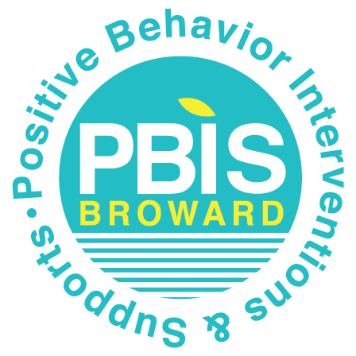
Staff Managed Misbehaviors | Office Managed Misbehaviors
Note: The behaviors provided are examples, not an exhausted list of misbehaviors.
Inappropriate language  - name calling  - use of profanity | Inappropriate language  - racial slurs or taunting  - profanity directed at a staff member
Disrespect  - talking back  - physical gestures | Harassment  - bullying  - threat or intimidation
Defiance  - work refusal  - head down on desk/sleeping  - not following directions | Defiance  - leaving classroom, assigned area, or school grounds without permission  - forgery/plagiarism
Disruptive  - tattling/false information  - talking out of turn  - calling out  distracting others | Disruptive  - inciting others to disrupt teacher  - chronic classroom disruption: more than 3 times within 30 minutes
Physical Contact  - touching others, pushing/shoving (no injuries)  - mutual horseplay | Physical Contact  - touching others (hitting, kicking, biting) with intent to do harm  - petty theft
Violation of classroom or location-specific rules | Violation of the Code of Student Conduct

CRITICAL ELEMENT # 8: Classroom Management Systems

8A. Evidence-based Tier 1 classroom management system:

Which evidence-based system(s) are you using? | Provide 3-4 measurable and observable action steps the team will take to help educators improve their classroom management system. (3-4 detailed steps)
☒ CHAMPS  ☐ Positive Behavior Interventions and Supports and the Classroom  https://fl-pda.org/#/category/26  ☐ Other: Click here to enter name of system. | 1. Provide information about how to register for CHAMPS professional developmnt.  2. Provide a district coach to teachers who need individualized support with behavior management.  3. Provide a school-wide plan of recognition where students earn Falcon Feathers and are recognized in the morning announcements.

8B. The administration reviews and analyzes the fidelity of staff implementation of Tier 1 classroom management systems across teachers using:


☒ CHAMPs 7 Up Checklist
☐ Classroom Snapshot (Classroom Management Assessment)
☐ PBIS Classroom Assistance Tool (CAT)
☐ Other (specify):

8C. Percentage of classroom referrals: Use current 2024-2025 school year behavior data as listed in Focus.
(a) Review your classroom data YTD in Focus – Discipline – Category Breakdown – Location.
(b) Complete the yellow highlighted cells.
(c) Auto-calculate the % of referrals in the classroom by clicking on “!Zero Divide” in the next cell and pressing “Fn + F9” together.

Total number of discipline referrals from classrooms: | 22
Total number of other school-wide discipline referrals (not including classrooms): | 33
% of referrals in the classroom: | 40%
Do more than 40% of your referrals come from the classroom? | ☐ Yes ☒ No
If >40% of discipline referrals come from the classroom, it suggests Tier 1 classroom management implementation may need to be strengthened school wide.

Critical Elements # 9: SPBP Implementation Planning
RED Font = Action Steps for all schools in Broward County
GREY Font = Best Practices for all schools in Broward County
TEAL Font = Resources available at https://browardschools.instructure.com/enroll/PWF673
Implementation Action Plan
Month | Action Steps  ☒ check off Action Step when completed
Current | ☒ Create an SPBP binder or portfolio to retain (for 2 years) hard copies of: your SPBPs, Action Plans, staff PBIS  professional development attendance, stakeholder training attendance, quarterly meeting agendas, quarterly staff  behavior presentations, voting attendance and outcome, Expectations lesson plans and Rules lesson plans
Pre-Planning | ☐ Print up your SPBP and Feedback form BCPS Central  ☒ Provide SPBP presentation to all staff during Pre-Planning  ☒ Disseminate the current SPBP (hard copy or electronically) to all staff and stakeholders  ☐ Market and post School-wide Expectations and Location-specific Rules  ☐ Identify your district PBIS Specialist  (Contact amber.jennings@browardschools.com for more information if you are unsure)  ☐ Ensure schedule of quarterly meeting dates for entire year as indicated in the SPBP (indicated in yellow)
August  1st Quarter Team Meeting | ☐ Determine any needed team training, such as: 4 Step Problem Solving Process series, PBIS 10  Critical Elements, Data Collection, etc.  ☐ Review previous year’s SPBP and feedback form; make necessary modifications  ☐ Review previous year’s data (Use Tier 1 Agenda and Quarter Big 5 Data template on PBIS Canvas page)  ☐ Verify and implement teaching schedule for Expectations and Rules behavior lesson plans  ☐ Implement the Reward System for all students as indicated in the SPBP  ☐ Ensure the Discipline Flow Chart is distributed to all staff and is being used as written  ☐ Present implementation data, behavior data, team activities and SPBP progress to entire staff  ☐ Ensure all teachers are using an evidence-based classroom management plan, such as CHAMPS  ☐ Confirm next quarterly PBIS team meeting date and time
September | ☐ Provide SPBP stakeholder presentation by September 30th  ☐ Ensure instructional staff know how to document Tier 1 Supplemental Strategies for behavior  ☐ Check for staff and teacher understanding of PBIS - provide “PBIS 101” training as a resource  Brainshark available at: http://www.brainshark.com/browardschools/PBIS101
October  2nd Quarter Team Meeting | ☐ Review previous quarter’s data. (Use Tier 1 Agenda and Quarter Big 5 Data template on PBIS Canvas page)  ☐ Present implementation data, behavior data, team activities, and SPBP progress to entire staff  ☐ Ensure Core Effectiveness Action Steps are being implemented as written  ☐ Complete Quarterly Big 5 Data Template and submit to your PBIS Administrator  ☐ Confirm next quarterly PBIS team meeting date and time
November | ☐ Review/revise lesson plans as indicated by previous quarter behavior data  ☐ Ensure that the Student Outcome Monitoring Action Steps are being implemented as written
January  3rd Quarter Team Meeting | ☐ Staff to re-teach Expectations and Rules after winter break  ☐ Review previous quarter’s data. (Use Tier 1 Agenda and Quarter Big 5 Data template on PBIS Canvas page)  ☐ Present implementation data, behavior data, team activities, and SPBP progress to entire staff  ☐ Complete Quarterly Big 5 Data Template and submit to your PBIS Administrator  ☐ Confirm next quarterly PBIS team meeting date and time
February | ☐ Check on recently hired staff for PBIS understanding - provide “PBIS 101” Brainshark resource  ☐ Utilize the Stakeholder SPBP Forms Survey to solicit input for planning next year’s SPBP (optional)
March  4th Quarter Team Meeting | ☐ Ensure progress towards completion and submission of next year’s SPBP  ☐ Staff to re-teach Expectations and Rules after spring break  ☐ Review previous quarter’s data. (Use Tier 1 Agenda and Quarter Big 5 Data template on PBIS Canvas page)  ☐ Present implementation data, behavior data, team activities, and SPBP progress to entire staff  ☐ Complete Quarterly Big 5 Data Template and submit to your PBIS Administrator
April | ☐ Provide staff presentation and faculty vote on new SPBP for next year  ☐ Submit your SPBP in BCPS Central by April 30th. Use this new SPBP in the next school year  ☐ Continue implementing your current SPBP through the end of the current school year

CRITICAL ELEMENT # 10: Evaluation
10A. Staff Implementation of the Schoolwide Positive Behavior Plan: review goals, evaluate implementation, and create 2 action steps to review in quarterly PBIS meetings.
“Are staff implementing the SPBP with fidelity? If not, how will you address this area?”
STAFF Implementation Monitoring
Staff Implementation Goal | Quarterly Team Review:  Implemented with fidelity? | If you answered No, enter 2 action steps your school will take to move towards this goal by the next PBIS meeting.
100% of hallways, front office, cafeteria, and other public areas all have school-wide expectations and location-specific rules posted. | ☐Yes ☐No | By Click here to enter a date,  1.  2.
100% of instructional staff has delivered expectations and rules lesson plans as written and when indicated. | ☐Yes ☐No | By Click here to enter a date,  1.  2.
100% of staff members are oriented to the Discipline Flow Chart. It is used consistently by 100% instructional staff, behavioral support, and administrators. | ☐Yes ☐No | By Click here to enter a date,  1.  2.
A recognition system is implemented by 100% staff for all students. | ☐Yes ☐No | By Click here to enter a date,  1.  2.

10B. The SPBP is successful in positively impacting students: review behavior data and create a SMART goal. Evaluate implementation and create action steps to review in quarterly PBIS meeting.
“If staff are implementing the SPBP consistently and effectively, is it positively impacting students? How will you know?”
SMART Criteria:
S | Specific | Concrete, detailed, focused, and well defined. Results-focused and action-orientated.
M | Measurable | The measurement sources (data) are defined numerically in order to track progress towards the objective.
A | Attainable | Objectives are achievable in the near future to maintain motivation.
R | Realistic | Staff have the resources to achieve the objective- time, personnel, materials, etc.
T | Time-bound | Agreed-on time frames create the necessary urgency and prompt action.

STUDENT Outcome Monitoring
Student Outcome Data | Complete the SMART goal to determine “successful” student outcomes (use numerical data) | List 2 action steps your team will take to ensure this goal is monitored and meets or exceeds the SMART goal.
Select an item  Choose one ODR area of focus | By June 3, 2026, the number of referrals in the dining room will indicate a decrease in number of referrals by at least two, from 12 to 10 or less, as measured by Office Discipline Referrals (ODRs) in Focus. | 1. The team will track quarterly referrals to progress monitor referral locations.  2. The team will track how often the incentives are earned.

SPBP Submission
- Upload completed SPBP (as PDF) into BCPS Central in the School Improvement Plan.
- Complete PBIS Point of Contact form.

