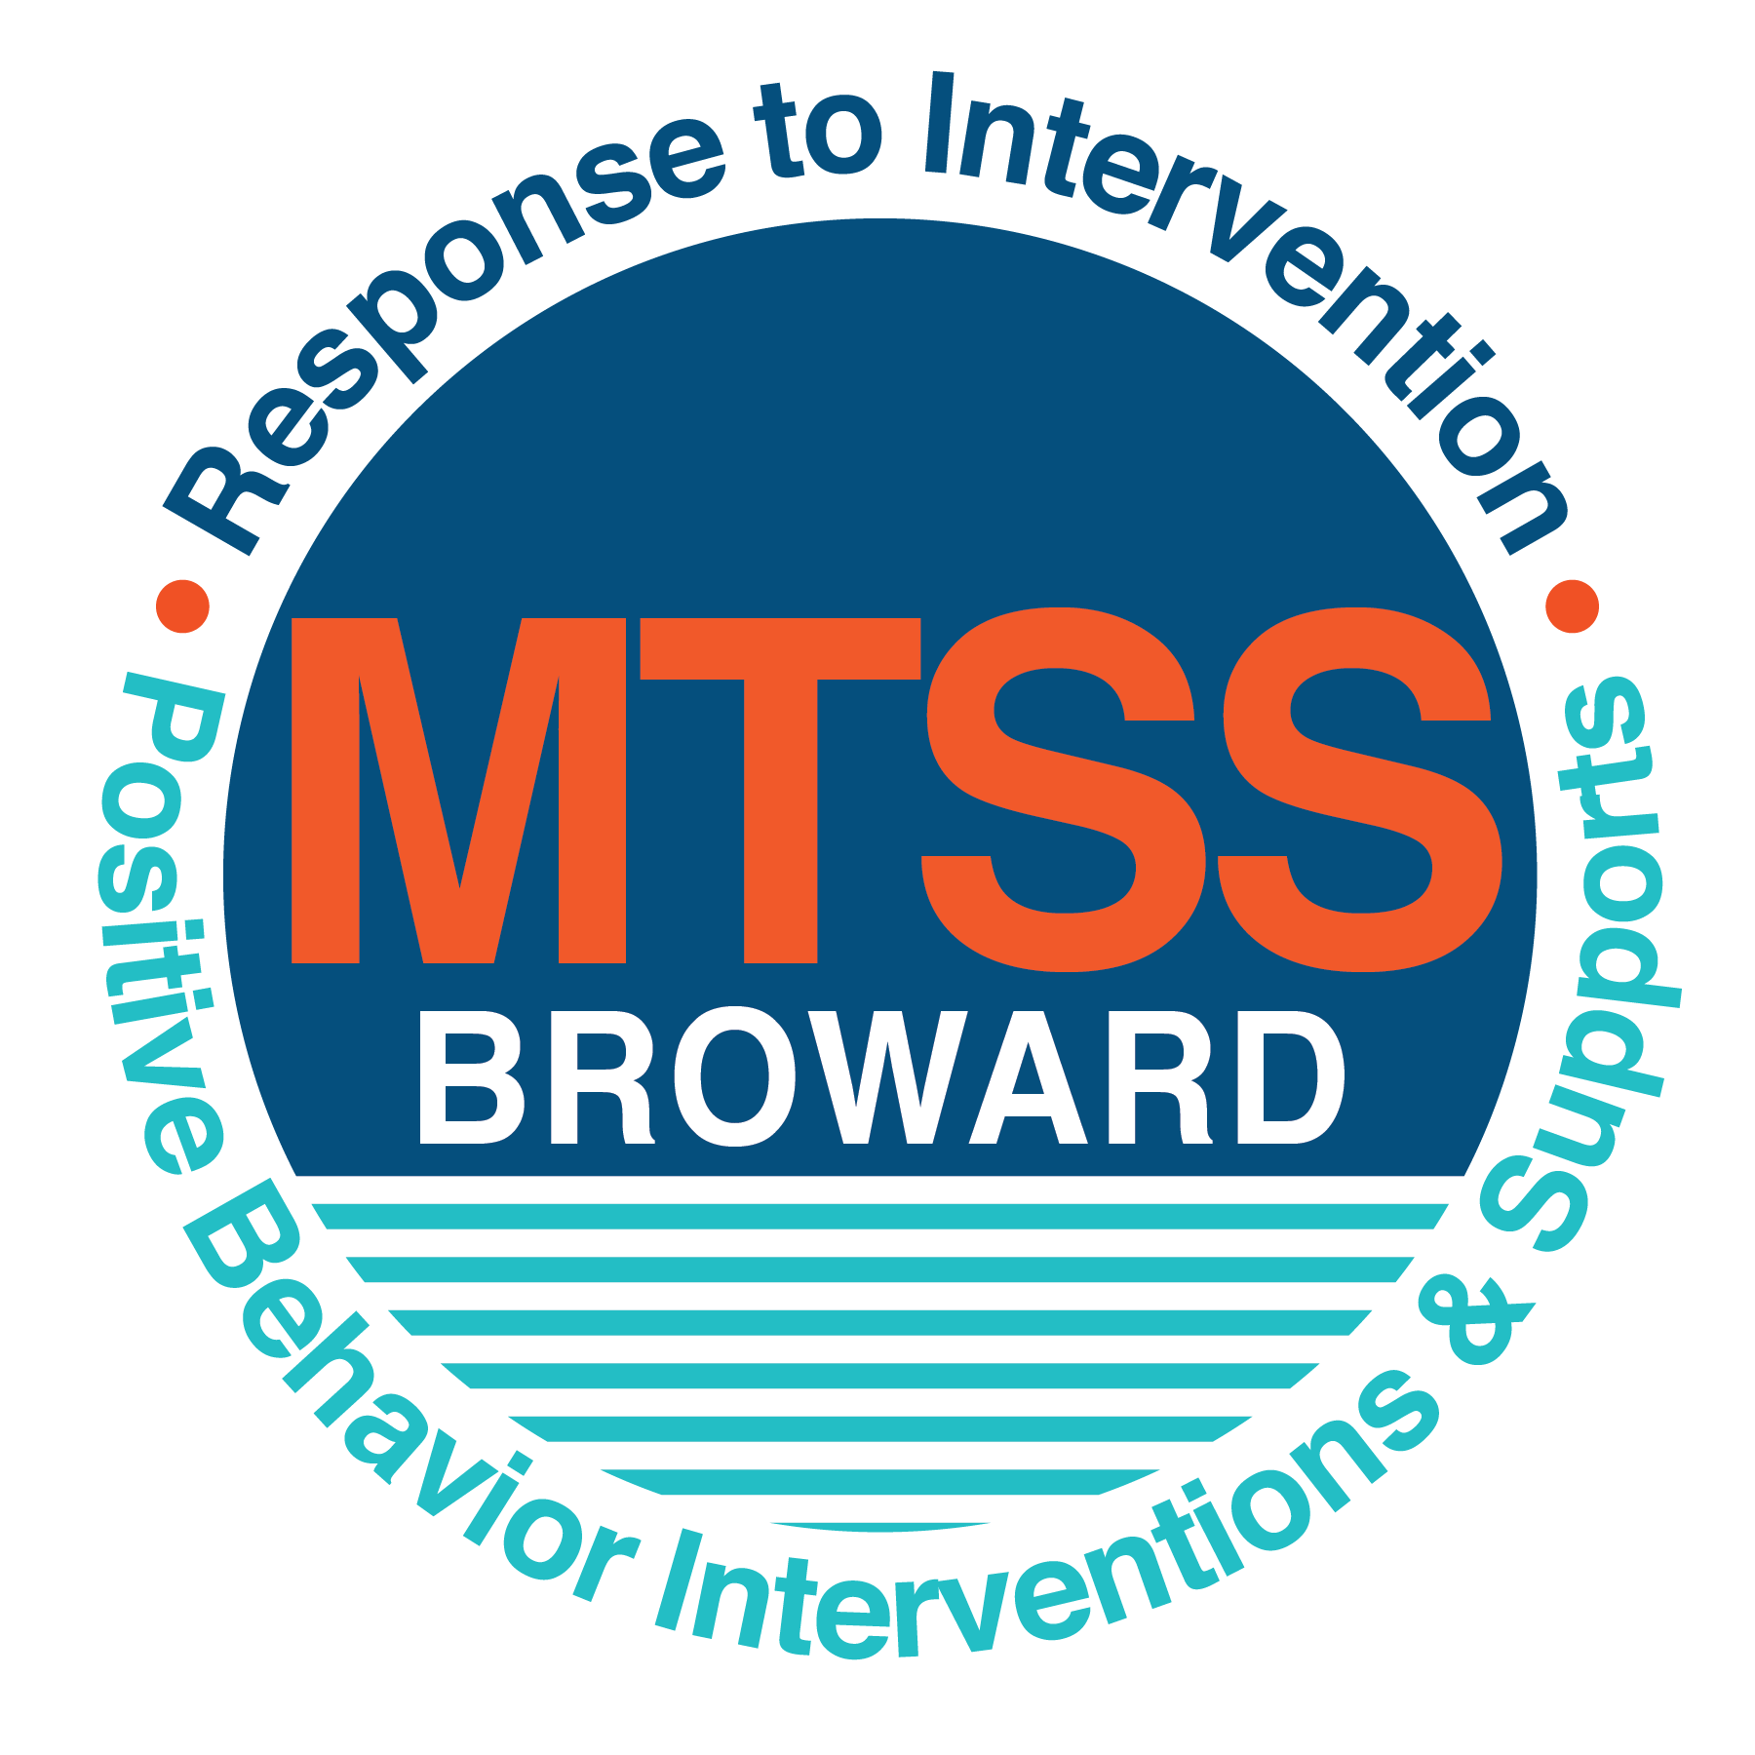
School-wide Positive Behavior Plan (SPBP)
Broward County Public Schools
To be implemented in SY 2020-21

School Name: | Dolphin Bay Elementary School
School Number: | 3751
SPBP Contact Name: | Cristina Deatherage
Direct Phone Number: | 754-323-8000

CRITICAL ELEMENT # 1: Active Team with Administrative Participation

1A. Team Members (SY 2019-20) who developed this SPBP:
Full Name | Position
Sandra Nelson | Principal
Cristina Deatherage | Assistant Principal/ SPBP Point of Contact
Thomas Dusch | BTU Representative/ SAC Chair
Danielle Gomez | Parent
Jeremy Scott | Community Representation
Canarissa Elliott | School Counselor
Danielle Law | K Teacher/ Pre-K & K Team Leader
Latanya Ibeawuchi | 1st Grade Teacher/ Team Leader
Michelle Kappelman | 2nd Grade Teacher/ Team Leader
Sara Osorio | 3rd Grade Teacher/ Team Leader
Carmen Alvarez | 4th Grade Teacher/ Team Leader
Michele DeCicco | 5th Grade Teacher/ Team Leader

1B. Schedule of quarterly SPBP Team Meeting dates for 2020-21 school year:
Meeting Date | Meeting Time | Content of meetings:
10/2/2020 | 2:15 PM | 1. Progress of Action Steps indicated in Implementation Plan in #9  2. Collect & analyze fidelity of staff implementation data in #10A  3. Collect & analyze student outcome data in #10B
11/6/2020 | 2:15 PM
2/5/2021 | 2:15 PM
4/2/2021 | 2:15 PM

CRITICAL ELEMENT # 2: Faculty & Stakeholder Commitment:

2A. Action Steps completed this year (SY 2019-20) that increased faculty and stakeholder knowledge of the new SPBP:

Action Steps: | Dates  (Between Jan 15 and  April 30, 2020) | Details  (Sign-in sheets in SPBP Binder)
Presented the new SPBP (for SY 2020-21) to staff | 4/27/2020 | # of participants = 44
Held a faculty vote on the new SPBP  (for SY 2020-21) | 4/27/2020 | # of participants =44  % approved =98%
Presented the new SPBP (for SY 2020-21) to stakeholders (parents and community) | 3/9/2020 | # of participants = 14

2B. Action Steps to be completed next year (SY 2020-21) to increase faculty and stakeholder knowledge and understanding of the new SPBP:

Action Steps: | Dates  (SY 2020-21) | Content  (Sign-in sheets in SPBP Binder)
Provide professional development on the 2020-21 SPBP for all staff | Prior to students’ 1st day:  8/12/2020 | The team will present the updates in the SPBP for the 2020-21 school year. All stakeholders will be provided with access to the SPBP. Feedback will be collected for future team meetings.
Present the 2020-21 SPBP to stakeholders  (parents and community) | Prior to Oct 1st, 2020  9/21/2020
Present the behavior data to all staff quarterly | 1. 9/8/2020 | The team will present:  - the team’s progress in the Implementation Plan in # 9.  - the fidelity of staff implementation data in #10A.  - the student outcome data in #10B.
Present the behavior data to all staff quarterly | 2. 11/10/2020
Present the behavior data to all staff quarterly | 3. 1/8/2021
Present the behavior data to all staff quarterly | 4. 3/19/2021

CRITICAL ELEMENT # 3: School-wide Expectations

3A. Top five behavior incidents data YTD as listed in BASIS 3.0
Top 5 Behavior Incidents
1. Threat Assessment/Non-Criminal
2. Unruly Disruptive Behavior
3. Battery Low Level
4. Fight/Minor Altercation
5. Disobedience/Insubordination

3B. School-wide expectations are 3 – 5 positive characteristics (not behaviors) that counteract the top school-wide misbehaviors above. ALL people on campus model these expectations.
School-wide Expectations
1. Respectful to others
2. Responsible for your actions
3. Behave in a safe manner
4.
5.

3C. At least one lesson plan for each school-wide expectation above is distributed to teachers during pre-planning SY 2020-21 and are maintained in the SPBP Binder.
Dates the school-wide expectations lesson plans are taught:
 | Date(s) | Time: | Location(s):
August | 8/19/2020 | 8:30am | Classrooms
January | 1/4/2021 | 8:30am | Classrooms
After Spring Break | 3/29/2021 | 8:30am | Classrooms

CRITICAL ELEMENT #4: Location-based Rules

4A. Top three school-wide locations for Behavior Events YTD 2019-20:
Top 3 Locations, not including Classroom:
School Location | # Incidents
1. Classroom | 21
2. Cafeteria | 6
3. Hallway | 4

4B. Expectations and Rules Chart for common areas of school campus: (next page)

School-wide Expectations and Rules Chart |  |  |  | Completed by each teacher:
School-wide  EXPECTATIONS | Hallway Rules | Cafeteria Rules | Click here to enter location:  Rules | Classroom Rules
Be respectful to others | I will use “indoor voices” when speaking.  I will greet and speak with  others in a positive manner.  I will walk nicely with my buddies to the requested location. | I will keep my food wrappings, straws, and other items on my tray.  I will raise my hand if I need help.  I will follow the adults’ instructions.  I will use my “indoor voice” when speaking with my friends. |  | I will greet and speak with  others in a positive manner.  I will raise my hand if I need help.  I will follow the adults’  instructions.  I will use “indoor voices” when speaking.
Be responsible for your actions | I will travel in an orderly and quiet manner.  I will stay behind the person in front of me.  I will go directly to the assigned area. | I will remain at my assigned  seat.  I will use my “indoor voice”.  I will only consume the food I bought/brought. |  | I will remain at my assigned  seat.  I will use my “indoor voice”.  I will raise my hand if I need help.  I will follow the adults’  instructions.
Behave in a safe manner | I will stay on the right side of  the hallway.  I will keep hands and feet to  myself.  I will use appropriate language. | I will wait my turn to empty my tray.  I will ask permission to use the restroom.  I will keep my hands and feet to myself. |  | I will follow the adults’  instructions.  I will keep hands and feet to  myself.  I will use appropriate language.

4C. At least one Rules lesson plan for each common location is distributed to teachers during pre-planning
SY 2020-21 and are maintained in the SPBP Binder.

Dates the Locations’ Rules lesson plans are taught
 | Date(s) | Time: | Location(s):
August | 8/19/2020 | 8:30am | Classrooms
January | 1/4/2021 | 8:30am | Classrooms
After Spring Break | 3/29/2021 | 8:30am | Classrooms

CRITICAL ELEMENT # 5: Reward and Recognition Programs

5. The reward system is focused on one School-wide Expectation OR specific location at a time.
Expectation OR Location: __________________________________

4 Step Problem Solving Process | Plan Details
1. Problem Identification: Use your behavior data to identify one school-wide problem.  What problem did you identify? (use numerical data) | Data used: Quarterly Behavior Incident Data located in Basis.  Problem Identification Statement: The highest referred incident at Dolphin Bay Elementary School was for unruly disruptive behavior which totaled 9 incidents. In addition, Dolphin Bay Elementary School had 21 referred incidents occur in the classroom which was the highest incident location.
2. Problem Analysis: Why do you think this problem is occurring?  What is your goal? (use a SMART goal statement with numerical data) | Hypothesis: Classroom positive behavior plans were not in complete alignment with district’s Positive Behavior Plan and teachers were not using the positive behavior plan with fidelity.  Goal Statement: By June 2021, Dolphin Bay Elementary School will reduce the number of incidents for unruly disruptive behavior by 10% evidenced by Quarterly Behavior Incident Data in Basis. By June 2021, Dolphin Bay Elementary School will reduce the number of referred incidents occurring in the classroom by 10% evidenced by the Quarterly Behavior Incident Data in Basis.
3. Intervention Design: Describe how you will implement a positive reward program to decrease this problem. | Type of System: Lottery  Description of System: Students will earn a raffle ticket and be entered into a  school wide drawing occurring three times a week for prizes each time they  demonstrate responsibility for their actions and exhibit an attitude of care and  respect towards their teachers, peers, and school environment as a whole. In  addition to earning a prize if their ticket is pulled in the school wide raffle, the  students will also be recognized on the morning announcements three times a  week and showcased for exhibiting responsibility and an attitude of care and  respect towards their teachers, peers, and school environment as a whole.  Students will receive an identifying bracelet to wear throughout the year to indicate  prior acknowledgement for their efforts. Students will report to a  designated area immediately following announcements to select their prize.  Recognition will begin the week of September 7, 2020 and run the entire school  year.
4. Evaluation:  A. Implementation fidelity | - How will you monitor the fidelity (consistency and effectiveness) of the staff’s implementation of the reward program? School counselor will collect data on names, grade levels, and classes of students who have earned rewards. This data will be organized to determine specific grade levels and classes where tickets are most and least distributed.
B. Student outcome monitoring (use numerical data) | - How will you know if the reward program is positively impacting students? What measurable data will you use to determine “success”? 100% of the classes should have a minimum of one student entered into the weekly raffle.

CRITICAL ELEMENT #6: Effective Discipline Procedures

Student Behavior Discipline Flow Chart
Consistently Teach and Re-Teach Tier 1 Rules/Expectations

Is the behavior minor?
Observe and identify
problem behavior
Is the behavior a crisis?
Is the behavior a referral?
Complete Discipline Referral and notify administration for consequences
Behavior is NOT corrected
“More than 3 misbehaviors in one hour”
- Out of assigned seat
- Calling Out
- Teasing
- Inattentive Behavior
- Minor Disruption
- Minor physical aggression
- Unsafe or rough play
- Misusing property/materials
- Pattern of incomplete homework
- Disrespectful behavior
- Tardiness
- Aggressive physical contact
- Bullying/Harassment
- Fighting
- Weapons
- Leaving School Property
- Pattern of aggressive/profane language
- Credible Threats
- Major/chronic destruction
- Major/chronic refusal to follow school rules
- Theft
- Cheating
- Inappropriate use of internet
- Direct refusal of authority
Administrative Managed
Teacher/Staff Managed
Administrative intervention implemented
Complete Discipline Referral and notify administration for consequences
Administration Follows Crisis Protocol
Contact Administration Immediately
Administration submits referral for data input
Administrative Action
Administration follows up with teacher/staff member
Refer to Administration
Reinforce/
reward student
Behavior is corrected between steps 1-3
3rd Step
Refer to Guidance for assistance with behavior correction and possible behavior plan

2nd Step
Implement teacher determined consequence
Parent contact
Re-Teach Expectation

1st Step
Verbal Warning
Re-teach expectation
Is the behavior considered administrative managed?
Is the behavior considered staff managed?
Is the behavior moderate?

CRITICAL ELEMENT # 7: Classroom Management Systems

7A. In SY 2020-21, ALL teachers implement an evidence-based Tier 1 classroom management system:
Evidence-based system: | Evidence of training:
☐ CHAMPS | % of teachers currently holding valid CHAMPS certificate =
☐ PBIS Classroom Management  http://www.fl-pda.org/independent/ | % of teachers currently holding completion certificate =
☒ Other: Zones of Regulation | Training evidence: Sign-in sheet(s)  % of teachers currently trained =90%

7B. The administration reviews and analyzes the fidelity of staff implementation of Tier 1 classroom management systems across teachers using:
☐ CHAMPs 7 Up Checklist
☐ Classroom Snapshot (Classroom Management Assessment)
☐ PBIS Classroom Assistance Tool (CAT)
☒ Other (specify): Marzano’s Domain 1, Design Questions 5,6,7,8,9

7C. School year 2019/20 YTD percentage of classroom referrals:
Total number of discipline referrals from classrooms: | 21
Total number of other school-wide discipline referrals (not including classrooms): | 16
% of referrals in the classroom: | 57%
Do more than 40% of your referrals come from the classroom? | ☒ Yes ☐ No
If >40% of discipline referrals come from the classroom, it suggests Tier 1 classroom management implementation may need to be strengthened school-wide.
If “Yes”, school-wide classroom management professional development will be conducted in 2020-21:
Other: If “Other”, indicated system here: Zones of Regulation

CRITICAL ELEMENT # 8: Data Collection and Analysis

8A. Core Effectiveness:
TOTAL Population: | 664 | % of Total Population | Core Effectiveness
# Referrals: | # of Students: | % of Total Population
0 - 1 referrals | 16 | 99% | Are your 0 – 1 referrals > 80%? | ☒Yes ☐No
2 - 5 referrals  (at risk students) | 7 | 1% | Are your 2 - 5 referrals <15%? | ☒Yes ☐No
> 5 referrals  (high risk students) | 0 | 0% | Are your >5 referrals <5%? | ☒Yes ☐No

8B. Core Effectiveness Action Steps:
If all 3 are “Yes”, your core is effective. Is your core behavior curriculum effective? | ☒Yes ☐No
Answer either (a) or (b):
(a) If you answered “Yes”, although your core is effective, what steps does your school leadership team take for early identification of at risk and high-risk students?
(b) If you answered “NO”, indicate the supports and interventions your school leadership team will implement at the beginning of the next school year to improve core strength:
Core Effectiveness Action Steps: (3-4 steps)
1. Hold monthly RtI meetings to discuss at risk and high-risk behavior students
2. Develop behavior plans to address the individual student needs of the at risk and high-risk behavior students
3. Teachers implement the individualized student behavior plans in their classrooms and collect data for four weeks
4. Bring the collected data to the next RtI meeting so the RtI team can discuss and decide whether to continue or modify the individualized student behavior plan

8C. Disproportionality within racial subgroups:
Subgroups | (PctPop - Green)  % of students | (PctRef - Blue)  % of referrals | Difference in referral composition | Positive value suggests disproportionality  (Is the value positive?)
Black | 29 | 29 | 0 | ☐Yes ☒No
Hispanic/Latin | 47 | 66 | 19 | ☒Yes ☐No
White | 10 | 3 | -7 | ☐Yes ☒No

8D. Disproportionality Action Steps:
If all three are “No”, disproportionality is not indicated. Are all 3 “No”? | ☐Yes ☒No
Answer either (a) or (b):
(a) If you answered “Yes”, although your data indicates equity, what plan does your school leadership team implement for early identification of any disproportionality issues
(b) If you answered “No”, indicate the support plan and interventions your school leadership team will implement at the beginning of next year to improve sub group disproportionality
Disproportionality Action Steps: (3-4 steps)
1. Hold monthly RtI meetings to discuss at risk and high-risk behavior students
2. Develop behavior plans to address the individual student needs of the at risk and high-risk behavior students
3. Teachers implement the individualized student behavior plans in their classrooms and collect data for four weeks
4. Bring the collected data to the next RtI meeting so the RtI team can discuss and decide whether to continue or modify the individualized student behavior plan

Critical Elements # 9: SPBP Implementation Planning
RED Font = Action Steps for all schools in Broward County
GREY Font = Best Practices for all schools in Broward County
TEAL Font = Resources available at https://browardcountyschools.sharepoint.com/sites/DPI6Strands/strand6/SitePages/SPBP.aspx
SPBP Team Implementation Action Plan 2020-21
Month | Action Steps  check when Action Step completed
Current | Create a SPBP binder or portfolio to retain (for 2 years) hard copies of: your SPBPs, Action Plans, staff PBIS  professional development attendance, stakeholder training attendance, quarterly meeting agendas, quarterly staff  behavior presentations, voting attendance and outcome, Expectations lesson plans and Rules lesson plans
Pre-Planning  2020 | ☐ Print up your SPBP Review and school score from OSPA  ☐ Provide SPBP presentation to all staff during Pre-Planning  ☐ Disseminate the current SPBP (hard copy or electronically) to all staff and stakeholders  ☐ Market and post school-wide Expectations and location-specific Rules  ☐ Identify your district MTSS Instructional Facilitator  (Contact tyyne.hogan@browardschools.com for more information, if you are unsure)  ☐ Confirm 1st team meeting date and time
August  1st meeting | ☐ Ensure schedule of quarterly meeting dates for entire year as indicated in the SPBP  ☐ Review Implementation plan; check off completed Action Steps  ☐ Determine any needed team training, such as these Brainsharks: 4 Step Problem Solving Process series, PBIS 10  Critical Elements, Data Collection, Big 5 Data, PBIS 101, etc. (All found in Sharepoint site)  ☐ Review previous year’s behavior data. (Use ‘Agenda’ Form and ‘Data Collection Template’ in Sharepoint site)  ☐ Utilize the 4 Step Problem Solving Process to initiate a Reward System for all students  ☐ Review previous year’s SPBP and feedback form; make necessary modifications  ☐ Verify and implement teaching schedule for Expectations and Rules behavior lesson plans  ☐ Present implementation data, behavior data, team activities and SPBP progress to entire staff
September | ☐ Provide SPBP stakeholder presentation prior to October 1  ☐ Check for staff and teacher understanding of PBIS - provide “PBIS 101” Brainshark as a resource  Brainshark available at: http://www.brainshark.com/browardschools/PBIS101  ☐ Ensure the Discipline Flow Chart is distributed to all staff and is being used as written
October  2nd meeting | ☐ Review Implementation plan; check off completed Action Steps  ☐ Ensure instructional staff know how to (and are, as needed) enter Tier 1 Supplemental Strategies  for behavior in BASIS  ☐ Review previous quarter’s behavior data. (Use ‘Agenda’ and ‘Data Collection Template’ in Sharepoint site)  ☐ Present implementation data, behavior data, team activities, and SPBP progress to entire staff  ☐ Ensure all teachers are using an evidence-based classroom management plan, such as CHAMPS  ☐ Ensure Core Effectiveness Action Steps are being implemented as written
November | ☐ Team to develop new and/or improved lesson plans as indicated by behavior data.  ☐ Ensure that the Disproportionality Action Steps are being implemented as written
January  2020  3rd meeting  Prepare for SY 2021/22 SPBP | ☐ Review Implementation plan; check off completed Action Steps  ☐ Staff to re-teach Expectations and Rules after winter break  ☐ Principal signs in and watches the new “SPBP for Principals” Brainshark: Due January 30th  ☐ Present implementation data, behavior data, team activities, and SPBP progress to entire staff  ☐ Choose team members and dates to work on, complete, and submit the new SPBP  ☐ Teams watch the new “SPBP Team Overview” Brainshark and refers to district resources and supports  (Brainsharks and Additional items in Sharepoint site. Webinars and in-person lab information in Team Brainshark)
February | ☐ Ensure progress towards completion of SPBP  ☐ Check on recently hired staff for PBIS understanding - provide “PBIS 101” Brainshark resource  ☐ Provide the SPBP Surveymonkey link to all staff (optional)
March  4th meeting | ☐ Ensure progress towards completion and submission of SPBP  ☐ Review Implementation plan; check off completed Action Steps  ☐ Staff to re-teach Expectations and Rules after from spring break  ☐ Provide stakeholders/parent presentation on new SPBP for next year  ☐ Provide staff presentation and faculty vote on new SPBP for next year  ☐ Present implementation data, behavior data, team activities, and SPBP progress to entire staff
April | ☐ Submit your SPBP in OSPA by April 30th every year. Use this new SPBP in the next school year  ☐ Continue implementing your current SPBP through the end of the current school year

CRITICAL ELEMENT # 10: Evaluation

10A. Staff implement the School-wide Positive Behavior Plan effectively:
“Are staff implementing the SPBP with fidelity? How will you know?”
STAFF Implementation Monitoring
Action Step | Create an observable and measurable SMART goal to determine “successful”  staff implementation of action step (use numerical data)
School-wide expectations and location-specific rules are posted across campus | 100% of the classrooms will have the school-wide expectations and rules posted in their classrooms by August 19, 2020
Expectations and Rules lesson plans are being taught as written and when indicated | 100% of teachers will have lesson plans that include Social Skills/Rules in their lesson plan books and have taught the lesson plan as written by August 28, 2020
The Discipline flow chart is being used by all staff as written | 100% of school staff will use the discipline consequences and flow chart as written from August 20220 through June 2021
A reward system is being implemented for all students | 100% of teachers will implement the school-wide reward system for all students as written from August 2020 through June 2021

10B. The SPBP is successful in positively impacting students:
“If staff are implementing the SPBP consistently and effectively, is it positively impacting students? How will you know?”
STUDENT Outcome Monitoring
Student Outcome Data | Create an observable and measurable SMART goal to determine  “successful” student outcomes (use numerical data)
Behavior Incident data  (See critical element #3A) | By June 2021, Dolphin Bay Elementary School will reduce the number of incidents for unruly disruptive behavior by 10% evidenced by the Quarterly Behavior Incident Data in Basis.
Top 3 event locations data  (See critical element #4A) | By June 2021, Dolphin Bay Elementary School will reduce the number of incidents in classroom, cafeteria, and hallway by 30%
Core effectiveness data  (See critical element #8A) | 80% of students with one referral will not receive a second referral within the nine-week period.
Classroom referrals data  (See critical element #7C) | By June 2021, Dolphin Bay Elementary School will reduce the number of referred incidents occurring in the classroom by 30% evidenced by the Quarterly Behavior Incident Data in Basis.

