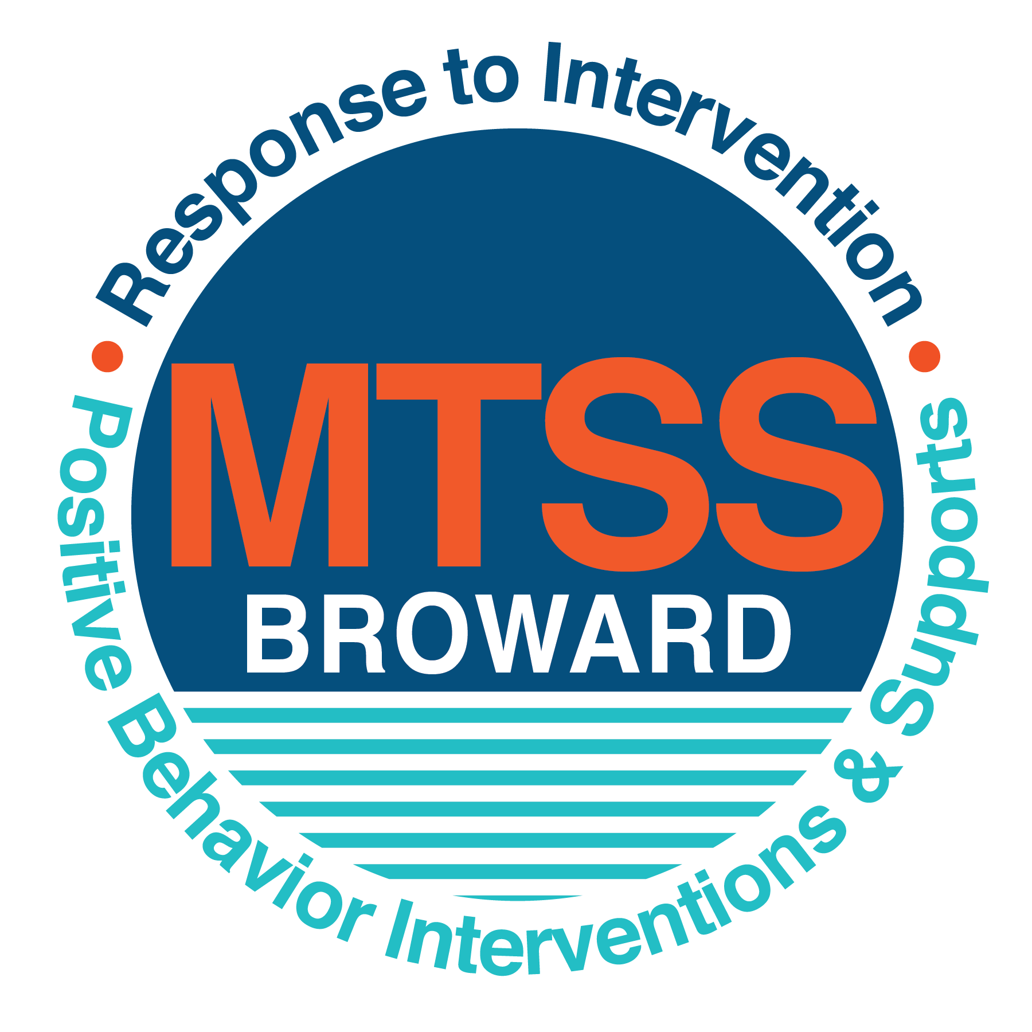
School-wide Positive Behavior Plan (SPBP)
Broward County Public Schools
To be implemented in SY 2018/19

Elements have changed in the SPBP.
Before completing, go to http://www.browardprevention.org/mtssrti/rtib/ → School-wide Positive Behavior Plan for:

- A NEW Brainshark for Principals. ACTION: Log in with your p # and watch the Brainshark before Jan 30th.
- A NEW Overview Brainshark for Teams. ACTION: Log in with school name and watch the Brainshark.
- A NEW mini Brainshark Series for teams. These Brainsharks are divided into the 10 Critical Elements of PBIS. They will
show you “how to” write a comprehensive SPBP (and receive a high score!)
- A Rating Rubric to ensure teams will correctly complete the SPBP and develop a meaningful plan.

To provide consistency across the District, only plans entered on the current district template will be accepted.
ACTION: Download, complete and upload the SPBP into your School Improvement Plan before May 1, 2018:

School Name: | Bennett Elementary
School Number: | 0201
SPBP Contact Name: | Amy Rubin
Direct Phone Number: | 754.322.5462

CRITICAL ELEMENT # 1: Active Team with Administrative Participation

1A. List your current (SY 2017/18) team members (6 - 10 team members). Must include an instructional representative from EACH grade/content area. Each name on this list verifies attendance in ongoing team meetings and participation in developing this SPBP. Each member is responsible for representing major stakeholders and sharing the SPBP content and updates with their respective group.
Full Name | Position | Who or what grade level does this member represent?
Danielle Smith | Principal | Administration
Amy Rubin | SPBP Point of Contact | School Counselor
Mrs. Jean-Paul | Parent/Community Representation | SAC
Danielle Wesley | BTU Representative | Kindergarten
Leslie Bragunier | Teacher | PreK ESE
Rebecca Morgado | Teacher | Resource Teacher / SAC Chair

1B. Schedule and document your quarterly team meeting dates for next 2018/19 school year:
Meeting Date | Meeting Time | Name & title of person responsible to facilitate meeting | Content of meetings:
9/25/2018 | 2:00 PM | Rubin/Bragunier | 1. Create and disseminate updated  Expectations and Rules lesson  plans (#3 and #4)  2. Review progress of  Implementation Action Plan (#9)  3. Collect & analyze implementation  data (#10A)  4. Collect & analyze student  outcome data (#10B)
11/27/2018 | 2:00 PM | Rubin/Bragunier
1/29/2019 | 2:00 PM | Rubin/Bragunier
4/30/2019 | 2:00 PM | Rubin/Bragunier

CRITICAL ELEMENT # 2: Faculty & Stakeholder Commitment:

2A. Action Steps completed this year (SY 2017/18) that increased faculty and stakeholder understanding and knowledge of your new (2018/19) SPBP:
Action Steps: | Date  (Between Jan 15 –  April 30, 2018) | Details  (retain attendance sheets at school) | Person responsible to collect and retain attendance sheets:
Presented the new SPBP (for SY 2018/19) to staff | 2/6/2018 | # of participants = 46 | Dawn Locascio
Held a faculty vote on the new SPBP  (for SY 2018/19) | 2/20/2018 | % approved = 100 | Dawn Locascio
Presented the new SPBP (for SY 2018/19) to stakeholders (parents and community) | 4/24/2018 | # of participants = 17 | Dawn Locascio

2B. Action Steps to be completed next year (SY 2018/19) to increase faculty and stakeholder understanding and knowledge of your SPBP:
Action Steps: | Date(s)  (NEXT YEAR) | Content  (retain attendance sheets at school) | Person responsible to collect and retain attendance sheets:
Provide a professional development on the 2018/19 SPBP for all staff | Prior to students’ 1st day:  8/8/2018 | The team will present the updates in the SPBP for the 18/19 school year. All stakeholders will be provided with access to the SPBP. Feedback will be collected for future team meetings. | Dawn Locascio
Present the 2018/19 SPBP to stakeholders (parents and community) | Prior to Oct 1st, 2018  9/18/2018 |  | Dawn Locascio
Present behavior data to staff  Quarterly: minimum of 4 each year | 1. 11/6/2018 | The team will present the implementation data in 10A. Include:  • the “marketing” (teaching and posting) of expectations and rules  • lesson plan implementation  • discipline procedures  • reward system implementation  The team will present the student outcome data in 10B. Include:  • top 3 event locations  • type of behavior incidents  • core effectiveness data  • classroom referral data, as well as analysis of this data. | Dawn Locascio
 | 2. 1/8/2019 |  | Dawn Locascio
 | 3. 3/5/2019 |  | Dawn Locascio
 | 4. 5/7/2019 |  | Dawn Locascio

CRITICAL ELEMENT # 3: School-wide Expectations

3A. List the top 10 behavior incidents data YTD from BASIS 3.0 Behavior Dashboard:
Top 10 Behavior Incidents
(put N/A in any blank spaces)
1.Disobedience/Insubordination | 6.Profanity to Staff
2.Insulting/Profane Language | 7.Assault/Threat – Non-criminal
3.Unruly/Disruptive Behavior | 8.Assualt/Threat – serious
4.Disruptive/Unruly Play | 9.Battery
5.Out of Assigned Area | 10. N/A

3B. Based on the behavior incidents in 3A, develop 3 – 5 positive characteristics (not behaviors) that would counteract the demonstration of these misbehaviors. These positive characteristics become your school-wide expectations.
School-wide Expectations
1.Be responsible
2.Be respectful
3.Be kind
4.Be Safe
5.Be positive

3C. Research indicates that discipline referrals increase after long holidays and during testing times. Plan to teach your expectations at least 3 times throughout the year (and anytime the expected behaviors are not being demonstrated).
ACTION: Create at least one lesson plan for each school-wide expectation above and distribute to teachers during pre-planning 2018-19. Develop additional lesson plans you will use throughout the year to re-teach and reinforce your school-wide expectations. You do not need to submit your lesson plans with the SPBP. Retain all behavior lesson plans at the school; make sure these lesson plans are available for guests and stakeholders.
When will school-wide expectations lesson plans be taught?
 | Date(s) | Time:
August | 08/15/2018 | As appropriate for each classroom.
January | 01/08/2019 | As appropriate for each classroom.
4th Quarter | 04/01/2019 | As appropriate for each classroom.
Who will be responsible for teaching the lesson plans? |  |  | Classroom Teacher
Where will the lesson plan instruction occur? |  |  | Classroom
Who is responsible for retaining, organizing and distributing all lesson plans? |  |  | Leslie Bragunier

CRITICAL ELEMENT #4: Location-based Rules

4A. List the top 3 locations for behavior Events YTD from BASIS 3.0 Behavior Dashboard. Do not use “classroom”
Top 3 Locations
School Location | # Incidents
1.Playground | 18
2.Specials | 09
3.Cafeteria | 07

4B. Create an Expectations/Rules Matrix from your 3-5 school-wide expectations and your top 3 event locations. Develop a positively stated, observable, and measurable rule that correlates with every expectation to create a maximum of 5 rules under each location.
Expectations and Rules Matrix
School-wide EXPECTATIONS | Copy and paste expectations from 3C. | IDENTIFIED LOCATIONS  Copy and paste locations from 4A.
School-wide EXPECTATIONS | Copy and paste expectations from 3C. | Classroom | Playground | Cafeteria
School-wide EXPECTATIONS | Copy and paste expectations from 3C. | Rules | Rules | Rules
School-wide EXPECTATIONS | Be Responsible | Complete all work and activities. Keep your area clean. Get permission. | Follow adult directions. Line up when the adult calls. | Eat your own food. Clean up your area.
School-wide EXPECTATIONS | Be Respectful | Raise your hand and wait. Have all materials ready. Eyes and ears on speaker. Use appropriate language. | Follow the game rules during play. Share equipment. | Sort voices. Use table manners. Listen to monitors.
School-wide EXPECTATIONS | Be Kind | Invite others to join activities. Use kind words. Share with others. | Invite others to play. Use kind words. | Say kind things. No gossiping.
School-wide EXPECTATIONS | Be Safe | Use supplies correctly. Keep hands and feet to yourself. Use walking feet. | Use equipment appropriately. Demonstrate self control. | Sit at your table. Stay in your seat. Raise your hand if you need assistance. Walk.
School-wide EXPECTATIONS | Be Positive | Be happy about learning. Come to school with a smile. Always try your best. | Promote good sportsmanship. Smile. Encourage others. | Say kind things. No gossiping.

4C. Research indicates that discipline referrals increase after long holidays and during testing times. Plan to teach your location-specific rules at least 3 times throughout the year (and anytime the expected behaviors are not being demonstrated).
ACTION: Create at least one lesson plan for each location above and distribute to teachers during pre-planning 2018-19. Develop additional lesson plans you will use throughout the year to re-teach and reinforce your location-specific rules.
You do not need to submit your lesson plans with the SPBP. Retain all behavior lesson plans at the school; make sure these lesson plans are available for guests and stakeholders.
When will location-specific rules lesson plans be taught?
 | Date(s) | Time:
August | 08/15/2018 | As appropriate for each classroom.
January | 01/08/2019 | As appropriate for each classroom.
4th Quarter | 04/01/2019 | As appropriate for each classroom.
Who will be responsible for teaching the lesson plans? |  |  | Classroom teachers
Where will the lesson plan instruction occur? |  |  | Classroom
Who is responsible for retaining, organizing and distributing all lesson plans? |  |  | Leslie Bragunier

CRITICAL ELEMENT # 5: Reward and Recognition Programs

Although you will post, teach, review, practice and reinforce all school-wide expectations and location-specific rules, choose 1 expectation OR 1 event location you will target for a specific reward program for students. Based on the data that led to this expectation or location, create a reward plan using the 4 Step Problem Solving Process:

Expectation or Location: Be Positive

4 Step Problem Solving Process | Plan
1. Problem Identification: Use your behavior data to identify a school-wide problem.  What problem did you identify? (use numerical data) | Data used: According to BASIS data, 25 incidences of unruly/disruptive behavior during the 2017-2018 academic year resulting in a referral; behavior most often referred.  Problem Identification: 25 incidences of unruly/disruptive behavior during the 2017-2018 academic year resulting in a referral; behavior most often referred.
2. Problem Analysis: Why do you think this problem is occurring?  What is your goal? (use a SMART goal statement with numerical data) | Hypothesis: Students may not understand behavior expectations. The school environment may not foster the appropriate behavior.  Goal Statement: Behavior referrals for unruly/disruptive behavior will decrease by 10% in the 2018-2019 academic year.
3. Intervention Design: Describe how you will implement a positive reward program to decrease this problem. | Type of System: Token system  Description of System: The school will implement the Passport to Peace program to foster a positive school environment. Praise and positive reinforcement of target behavior will aid in decreasing unruly and disruptive behavior.
4. Evaluation:  A. Implementation fidelity | - How do you monitor the fidelity (consistency and effectiveness) of the staff’s implementation of the reward program? Students will wear lanyards displaying the target behavior or attitude for each area. Staff will be required to identify students demonstrating specific attitudes. The school counselor will guide staff with implementation of specific attitudes for different time periods.
B. Student outcome monitoring | - How will you know if the reward program is positively impacting students? What measurable data will you use to determine “success”? The leadership team will monitor referable offenses and the reason for each offense using BASIS.

CRITICAL ELEMENT #6 Effective Discipline Procedures

6A. Staff Managed Misbehaviors: List the top 6 most common school-wide misbehaviors staff are expected to manage.
Write a short, objective, and measurable definition for each.
Staff Managed Misbehaviors
Misbehavior | “Looks Like” - provide a description with example(s)
1.Disobedience/insubordination | Refusal or failure to obey rules, out of seat/area, making inappropriate comments/remarks
2.Disruptive/unruly play | Interacting with others without self-control
3. Aggressive behavior/bullying | Students may verbally/physically harass others, intimidation, name-calling
4. Limited work completion | Fail to study, submit incomplete work, no work submitted, demonstrate lack of interest/involvement
5.Classroom disruption/Disruption of instruction | Distracting others during academic time with words, objects, physical proximity to others
6.Vandalism (under $100) | Classroom items/objects may be used inappropriately, damaged

6B. Staff Managed Consequences: Create a consequence menu OR a consequence hierarchy for staff to use when students exhibit the above misbehaviors. Provide a minimum of 5 consequences.
Is this a menu or hierarchy system? | ☒ Menu ☐Hierarchy
Phone call/note to parent
Detention
Loss of privilege/activity
Active resolution/logical consequence
Parent/teacher conference with administrator present

6C. Administration Managed Misbehaviors:
(a) Define the first 3 behaviors by providing examples that clearly identify the point at which the misbehavior warrants an Office Discipline Referral (ODR).
(b) List two additional common school-wide misbehaviors that will result in an ODR. Provide concrete examples.
(c) Determine staff tolerance level for repetitive misbehaviors (the point at which the number of staff-managed misbehaviors becomes an ODR).
Office Discipline Referrals (ODRs)
Behavior | “Looks Like” - provide a description with example(s)
1.Disobedience/insubordination | Refusal or failure to obey rules, out of seat/area, making inappropriate comments/remarks repeatedly and/or to the point of endangering the safety of self or others with behavior
2.Disruptive/unruly play | Interacting with others without self-control repeatedly and/or to the point of endangering the safety of self or others
3. Aggressive behavior/bullying | Students may verbally/physically harass others, intimidation, name-calling repeatedly and/or to the point of endangering the safety of self or others
4. Physical aggression | Students interacting with teacher or peers in a physically-aggressive manner: hitting, kicking, biting, throwing objects.
5. Vandalism/theft of item over $200 | Student breaks or takes item without permission from peer, teacher, school premises that is valued over $200 (technology/equipment, furniture)
6. Repetitive staff managed  misbehaviors | More than misbehaviors in warrants an office referral.  min  30  3  e.g., 3 half hour  2 one period

6D. School-wide Discipline Flow Chart:
(a) Review the sample discipline flow charts in “Additional Items” located on browardprevention.org
(b) Copy or customize a flow chart to graphically represent the discipline process at your school.
(c) Paste the flow chart here OR complete the flow chart below.

Student Behavior Discipline Flow Chart
Observe Problem Behavior
Intervene and redirect
Office Managed Misbehaviors
Staff Managed Misbehaviors
•Call to notify office of major infraction
•Write ODR
Implement an initial consequence from 6B
Is behavior Office Managed?
(if unsure, check below)

List Staff Managed  Misbehaviors from 6A | List Office Managed  Misbehaviors from 6C
Disobedience/insubordination  Disruptive/unruly play  Aggressive behavior/bullying  Limited work completion  Classroom disruption/Disruption of instruction | Disobedience/insubordination  Disruptive/unruly play  Aggressive behavior/bullying repeatedly and/or to the point of endangering the safety of self or others

Contact parent
Follow steps of matrix
Loss of privilege
Active resolution
Parent/teacher
Conference with admin

CRITICAL ELEMENT # 7 : Classroom Management Systems

7A. ALL teachers implement an effective Tier 1 classroom management system:
Which evidence-based classroom management system is supported by your school’s administration and is expected to be implemented school-wide?  (Class Dojo, LEAPs, HERO, Cloud 9, etc. are tools, not classroom systems) | ☐ CHAMPs*  ☐ PBIS Classroom Management  ☐ Administration does not expect an evidence-based classroom management system to be implemented by teachers this year  (your school will need to adopt one next year)  ☒ Other (complete below)
If other, name the evidence-based classroom management system: | Passport to Peace
*CHAMPs is the district-supported, evidence-based universal classroom management system for all teachers. Would your Principal like to be contacted to learn about CHAMPs professional development? | ☐ Yes ☒ No

7B. Fidelity of staff implementation of school-wide classroom management systems
What data collection tool does your school leadership team use to monitor and evaluate your teacher’s classroom management skills? (Measure staff skills, not student outcomes)
☐ CHAMPs 7 Up Checklist
☐ CHAMPs Classroom Check Up (CCU)
☐ PBIS Classroom Assistance Tool (CAT)
☐ PBIS Walkthrough
☐ Marzano’s Domain 1, Design Questions 5, 6, 7, 8, 9
☐ Fidelity of staff classroom management implementation is not monitored to determine training needs this year (you will need to adopt a tool and plan next year)
☒ Other (specify): Passport to Peace
Explain how this data is collected and analyzed by your school leadership team as a universal screening across teachers to determine the need for classroom management training:
Fidelity of Implementation Plan: (3-4 sentences)
Passport to Peace encourages 12 attitudes (confidence, independence, commitment, cooperation, creativity, empathy, respect, tolerance, enthusiasm, curiosity, honesty and appreciation. Every three weeks the entire school works on an attitude. The teachers are given twelve lanyards that hand in the room; visible for all to see. When someone in the class displays the attitude, the teacher takes a moment to explain how the student displayed it and the student wears the lanyard for the rest of the day. The student is recognized for demonstrating the attitude by school staff and peers.

7C. Percentage of Classroom Referrals:
(a) Review your classroom data YTD (“Events by Location”) in BASIS 3.0 Behavior Dashboard.
(b) Complete the yellow highlighted cells first.
(c) Auto-calculate the % of referrals in the classroom by clicking on “!Zero Divide” in the next cell and pressing “Fn + F9” together.
Total number of discipline referrals from classrooms: | 101
Total number of school-wide discipline referrals: | 102
% of referrals in the classroom: | 99%
Do more than 40% of your referrals come from the classroom? | ☒ Yes ☐ No
If >40% of discipline referrals come from the classroom, it suggests Tier 1 classroom management implementation may need to be strengthened school-wide.

CRITICAL ELEMENT # 8: Data Collection and Analysis

8A. Determine your School-wide Core Effectiveness YTD from the BASIS Behavior Dashboard in the “Referrals per Student” chart.
(a) Complete the yellow highlighted cells first.
(b) Auto-calculate the “% of Total Population” by clicking on each “!Zero Divide” in the cells and pressing “Fn + F9”.
(c) Determine if the core is effective in all three areas
TOTAL Population: | 438
# Referrals | 102 | % of Total Population | Core Effectiveness
0 - 1 referral | 22 | 96% | Are your 0 – 1 referrals > 80%? | ☒Yes ☐No
2 - 5 referrals  (at risk students) | 10 | 2% | Are your 2 - 5 referrals <15%? | ☐Yes ☒No
> 5 referrals  (high risk students) | 6 | 1% | Are your >5 referrals <5%? | ☐Yes ☒No

8B. Core Effectiveness Plan:
If all 3 are “Yes”, your core is effective. Is your core behavior curriculum effective? | ☐Yes ☒No
Answer either (a) or (b):
(a) If you answered “Yes”, although your core is effective, what plan does your school leadership team implement for early identification of at risk and high risk students?
(b) If you answered “NO”, indicate the supports and interventions your school leadership team will implement at the beginning of the next school year to improve core strength:
Core Effectiveness Plan: The leadership team plans to implement Passport to Peace in the 2018-2019 academic year. Passport to Peace encourages 12 attitudes (confidence, independence, commitment, cooperation, creativity, empathy, respect, tolerance, enthusiasm, curiosity, honesty and appreciation. Every three weeks the entire school works on an attitude. The teachers are given twelve lanyards that hand in the room; visible for all to see. When someone in the class displays the attitude, the teacher takes a moment to explain how the student displayed it and the student wears the lanyard for the rest of the day. The student is recognized for demonstrating the attitude by school staff and peers.

8C. Disproportionality: Determine if there are any issues within subgroups from BASIS 3.0 Behavior Dashboard in the “Referrals by Demographics” chart.
(a) Complete the yellow highlighted cells first.
(b) Auto-calculate the difference by clicking on each “0” in the next cell and pressing “Fn + F9”.
Subgroups | (PctPop - Green)  % of students | (PctRef - Blue)  % of referrals | Difference in referral composition | Positive value suggests disproportionality  (Is the value positive?)
Black | 87 | 90 | 3 | ☒Yes ☐No
Hispanic/Latin | 5 | 3 | -2 | ☐Yes ☒No
White | 8 | 7 | -1 | ☐Yes ☒No

8D. Disproportionality Plan: If any values are positive, the percentage of referrals contributed to that subgroup is higher than expected, given that subgroups’ percentage in the student population.
If all 3 are “No”, disproportionality is not indicated. Are all 3 “No”? | ☐Yes ☒No
Answer either (a) or (b):
(a) If you answered “Yes”, although your data indicates equity, what plan does your school leadership team implement for early identification of any disproportionality issues
(b) If you answered “No”, indicate the support plan and interventions your school leadership team will implement at the beginning of next year to improve sub group disproportionality
Disproportionality Plan: In addition to the implementation of the Passport to Peace program, the leadership team will take steps to address the specific areas of disproportionality by targeting areas of plan implementation. For example, the team may identify inadequate plan implementation, misunderstanding of school-wide expectations, academic achievement gap, disproportionality across all/specific settings, lack of student engagement. The leadership team will assist the faculty/staff with understanding the need for change, identifying areas for improvement, determining appropriate action, ensure that efforts to reduce disproportionality are effective, and guide necessary system adjustments. (Morris & Barnes, Disproportionality Data Guide; Using Discipline Data within SWPBIS to Identify and Address Disproportionality)

Critical Elements # 9: SPBP Implementation Planning

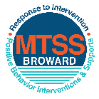
This form provides a timeline to complete best practices and required actions. This timeline should drive team actions and accountability. As you implement your SPBP NEXT year, check off completed items and indicate the accountable person. (Complete only the yellow highlighted area at this time). Next year, you will upload this completed plan within your SPBP.

Required actions for all schools in Broward County
Best Practices for all schools in Broward County
Resources
SPBP Team Implementation Action Plan 2018 - 2019
Month | Action Step  ☒ check when Action completed | Completed:  Person Responsible  Name & Title
Current | ☒ This Action Plan has been saved to use next year during quarterly meetings | Amy Rubin, School Counselor
Current | ☒ Create a SPBP binder or portfolio to retain (for 2 years) hard copies of: your SPBPs, Action Plans, staff PBIS professional development attendance, stakeholder training attendance, quarterly meeting agendas, quarterly staff behavior presentations, voting attendance and outcome, Expectation lesson plans and Rules lesson plans | Amy Rubin, School Counselor
Pre Planning  2018 | ☐ Print up your SPBP Review and school score from OSPA  ☐ Provide SPBP presentation to all staff during Pre Planning  ☐ Disseminate the current SPBP (hard copy or electronically) to all staff and stakeholders  ☐ Market and post school-wide Expectations and location-specific Rules (posters, PSAs, etc.)  ☐ Identify your RtI Instructional Facilitator provided by the district  (Contact tyyne.hogan@browardschools.com for more information, if you are unsure)  ☐ Confirm 1st team meeting date and time | Click here to enter NAME & title.
August  1st meeting | ☐ Ensure schedule of quarterly meeting dates for entire year as indicated in the SPBP  ☐ Determine any needed team training, such as the 4 Step PSP Brainshark Series, 10 Critical  Elements Brainsharks, Data Collection, Effective CPST Teams, PBIS 101, etc.  Trainings available at: http://www.browardprevention.org/mtssrti/training-modules/  ☐ Review previous year’s behavior data. (Use ‘Agenda’ and ‘Data Collection Template’)  Forms available at: http://www.browardprevention.org/mtssrti/rtib in Tier 1, Teaming  ☐ Present implementation data, behavior data, team activities and progress to entire staff  ☐ Utilize the 4 Step Problem Solving Process to develop initial interventions  ☐ Review previous year’s SPBP and feedback form  ☐ Verify and implement teaching schedule for SPBP Expectations and Rules behavior lesson plans | Click here to enter NAME & title
September | ☐ Provide stakeholder presentation on SPBP prior to October 1  ☐ Check for staff and teacher understanding of PBIS - provide “PBIS 101” Brainshark as a resource  Brainshark available at: http://www.brainshark.com/browardschools/PBIS101 | Click here to enter NAME & title.
October  2nd meeting | ☐ Ensure instructional staff know how to (and are, as needed) enter Tier 1 Supplemental Strategies  for behavior in BASIS  ☐ Present implementation data, behavior data, team activities and progress to entire staff | Click here to enter NAME & title.
November | ☐ Staff to re-teach Expectations and Rules first day back from break.  ☐ Team to develop new and/or improved lesson plans as indicated by behavior data. | Click here to enter NAME & title
January  2019  3rd meeting  Prepare for 2019/20 SPBP | ☐ Staff to re-teach Expectations and Rules first day back from break  ☐ Ensure the Principal signs in and watches the new SPBP Brainshark: Due January 30th  ☐ Present implementation data, behavior data, team activities and progress to entire staff  ☐ Choose team members and dates to work on, complete, and submit the new SPBP  ☐ Teams watch the new SPBP Brainsharks and refers to new “Additional items”  Brainsharks and Additional items posted at: http://www.browardprevention.org/mtssrti/rtib | Click here to enter NAME & title.
February | ☐ Ensure progress towards completion of SPBP  ☐ Check on recently hired staff for PBIS understanding - provide “PBIS 101” Brainshark resource  ☐ Provide the SPBP Surveymonkey link to all staff (optional). Email Tyyne.hogan@browardschools.com to request analysis. | Click here to enter NAME & title
March  4th meeting | ☐ Ensure progress towards completion of SPBP  ☐ Provide staff presentation and vote on new SPBP for next year  ☐ Provide stakeholders/parent presentation on new SPBP for next year  ☐ Present implementation data, behavior data, team activities and progress to entire staff | Click here to enter NAME & title
April | ☐ Submit your SPBP in OSPA by April 30th every year | Click here to enter NAME & title

CRITICAL ELEMENT # 10: Monitoring Plans

10A. How will you determine the success of staff implementation of the School-wide Positive Behavior Plan?
“Are staff implementing the SPBP with fidelity? How do you know?”
Fidelity of Implementation Monitoring Plan
Action Step | Create an observable and measurable SMART goal to determine “successful”  staff implementation of action step | When will data be collected, analyzed & presented? | Person responsible to collect and analyze data
School-wide expectations and location-specific rules are posted across campus |  | Refer to quarterly presentation dates in 2B.  This is the data the team will be sharing during presentations. | Amy Rubin
Behavior lesson plans are being taught as written and when indicated |  |  | Amy Rubin
Discipline consequences and flow chart are being used by all staff as written |  |  | Amy Rubin
A reward system is being implemented for all students |  |  | Amy Rubin

10B. How will you determine whether the SPBP is successful in positively impacting students?
“If staff are implementing the SPBP consistently and effectively, did it positively impact the students? How do you know?”
Student Outcome Monitoring Plan
Student Outcome Data | Create an observable and measurable SMART goal to determine “successful”  student outcomes | When will data be collected, analyzed & presented? | Person responsible to collect and analyze data
See critical element 3A  • Type of behavior incidents data |  | Refer to quarterly presentation dates in 2B.  This is the data the team will be sharing during presentations. | Click here to enter name
See critical element 4A  • Top 3 event locations data |  |  | Click here to enter name
See critical element 8  • Core effectiveness data |  |  | Click here to enter name
See critical element 7A  • Grade Level/Classroom referrals data |  |  | Click here to enter name

